

**MENTOREA**

“Your Path to Progress, Guided by Experts”

**PLATFORM**





|  |
| --- |
|  |
| Prepared by: |
| |  |  | | --- | --- | | Mahmoud Kamal | Abdallah Emad Eldin | | Hassan Hany | Ahmed Mahmoud | | Mahmoud Fawzy | Ahmed El-Sayed Ahmed |   Supervised by:  Dr. Hebatulla M. Nabil  Eng. Tasneem Mohamed  2024/2025 |

# ACKNOWLEDGEMENT

We would like to take this their opportunity to extend our their sincere gratitude and deep appreciation to our dedicated supervisor, Dr. Hebatulla M. Nabil and Eng. Tasneem Mohamed, for exceptional guidance and unwavering encouragement throughout the course of this project. support, assistance, and wisdom have been invaluable and will continue to guide us on our journey ahead. We also wish to express our thanks to the Board of the Faculty of Computers and Information for their support and for providing us with all the necessary resources. Finally, we are grateful to the Almighty, our team, our parents, and all the individuals who helped, supported, and motivated us to successfully complete our graduation project, whether they were from the university or the industry.

# 

# ABSTRACT

Mentorship is a critical factor in personal and professional development, yet access to experienced mentors can be limited due to geographic or social barriers. In this work, a platform called **Mentorea** has been developed to address these limitations by creating a comprehensive system for facilitating mentor-mentee relationships. Mentorea enables users to connect with industry experts, schedule mentorship sessions, and communicate effectively through chat or video calls. The platform employs a user-friendly interface that allows mentees to find suitable mentors based on expertise and availability. By streamlining the mentorship process, Mentorea aims to bridge the gap between aspiring professionals and experienced mentors, fostering meaningful interactions that enhance career development. The system has been designed to ensure scalability and security, providing a reliable solution for users worldwide. This project demonstrates the technical development and implementation of such a platform, utilizing modern web technologies to meet the growing demand for accessible mentorship opportunities.

# TABLE OF CONTENTS

ACKNOWLEDGEMENT 3

ABSTRACT 4

TABLE OF CONTENTS 5

List OF FIGURES 10

Chapter 1: Introduction 13

1.1 Introduction: 13

1.2 Problem Definition: 13

1.2.1 Mentor’s Perspective: 14

1.2.2 Mentee’s Perspective 14

1.3 Solutions for the Problem: 14

1.3.1 Solutions for Mentors 14

1.3.2 Solutions for Mentees 15

1.4 Project Objectives: 15

1.5 Project Scope: 16

1.6 Project Target Audience: 16

Chapter 2: Literature Review 18

2.1 Introduction 18

2.2 The Importance of Mentorship 18

2.3 Challenges in Traditional Mentorship Models 19

2.4 Opportunities for Digital Mentorship Platforms 19

2.5 Potential Challenges of Digital Mentorship Platforms 20

2.6 Review of Existing Digital Mentorship Platforms 20

2.7 Potential Solutions for Improvement 21

2.8 Similar Systems 21

2.9 Conclusion 22

23

Chapter 3: Project Management 23

3.1 Introduction 24

3.2 Project Plan 24

3.3 Project Management Activity 26

3.4 Risk Identification 28

3.5 Project Scheduling 29

30

Chapter 4: System Analysis & Design 30

4.1 Introduction 31

4.2 System Overview 31

4.3 Stakeholder Identification 32

4.4 Stakeholder Identification 33

4.4.1 Functional Requirements 33

4.4.2 Non-Functional Requirements 34

4.5 User Requirements 35

4.5.1 For Mentor 35

4.5.2 For Mentee 35

4.6 Use Case Diagram 36

37

4.7 Use Case Analysis 38

4.8 Activity Diagram 49

4. 9 System Sequence Diagram 52

4.10 Class Diagram 55

4.11 Data Flow Analysis 56

4.12 Entity Relationship Diagram (ERD) 57

4.13 Relational Database Mapping 58

4.14 Artificial intelligence (AI) 59

5.1 Introduction 66

5.2 Mentorea Main Functions 66

5.2.1 Functions for Mentors: 66

5.2.2 Functions for Mentees: 66

5.3 UI design in Figma 67

5.3.1 Application Screenshots for UI 67

5.4 Mobile application implementation 78

5.4.1 Feature Structure and Workflow 79

5.4.2 Authentication Process and State Handling 81

5.4.3 Flutter Security Considerations 84

5.5 Backend implementation 85

5.5.1 Introduction 85

5.5.2 Account/Profile API Endpoints 85

5.5.3 Authentication & Authorization API Endpoints 86

5.5.4 Availability Time API Endpoints 87

**Figure 49 Availability Time API Endpoints** 87

5.5.5 Card API Endpoints 88

5.5.6 Chat API Endpoints 88

5.5.7 Comment API Endpoints 89

5.5.8 Dashboard API Endpoints 90

5.5.9 Device Token API Endpoints 90

5.5.10 Field API Endpoints 91

5.5.11 Follow API Endpoints 91

5.5.12 Like API Endpoints 92

5.5.13 Post API Endpoints 92

5.5.14 Result API Endpoints 93

5.5.15 Role API Endpoints 93

5.5.16 Session API Endpoints 94

5.5.17 Specializations API Endpoints 95

5.5.18 User API Endpoints 96

6.1 Abstraction 98

6.2 Mentorea Recommendation System 98

6.2.1 Introduction 98

6.2.2 System Overview 98

6.2.3 Technical Implementation 99

6.2.3.1 Dependencies and Setup 99

6.2.3.2 Data Loading 99

6.2.3.3 Recommendation Logic 100

6.2.3.4 API Endpoint 100

6.2.4 Deployment on Railway 101

6.2.5 Conclusion 103

6.3 CV Checker for Mentorea Platform 104

6.3.1 Introduction 104

6.3.2 System Overview 105

6.3.3 Technical Implementation 105

6.3.3.1 Dependencies and Setup 105

6.3.4 Deployment 107

6.4 Sentiment Analysis 109

6.4.1 Introduction 109

6.4.2 System Overview 110

6.4.3 Technical Implementation 110

6.4.3.1 Dependencies and Setup 110

6.4.4 Deployment 111

Conclusion 113

Future Work 114

# List OF FIGURES

Figure 1 Comparative Table 20

Figure 2 Project Scheduling Gantt Chart 27

Figure 3 Use Case Diagram 35

Figure 4 Use Case Scenario : SignUp 36

Figure 5 Use Case Scenario : Login 37

Figure 6 Use Case Scenario : Profile Management 38

Figure 7 Use Case Scenario : Navigate Mentors 39

Figure 8 Use Case Scenario : Real-Time Communication 40

Figure 9 Use Case Scenario : Book Session 41

Figure 10 Use Case Scenario : Participate in the Community 42

Figure 11 Use Case Scenario : Session Feedback 43

Figure 12 Use Case Scenario :Receive Money 44

Figure 13 Use Case Scenario : Manage Platform 45

Figure 14 Use Case Scenario : Manage Platform 46

Figure 15 Activity Diagram : Mentee 47

Figure 16 Activity Diagram : Mentor 48

Figure 17 Activity Diagram : Admin 49

Figure 18 Sequence Diagram : Register 50

Figure 19 Sequence Diagram : Login 51

Figure 20 Sequence Diagram : 52

Figure 21 Class Diagram 53

Figure 22 Data Flow Diagram 54

Figure 23 Entity Relationship Diagram 55

Figure 24 Relation Database Mapping 56

Figure 25 Splash Screen 65

Figure 26 Onboarding 66

Figure 27 Account Type Selection 67

Figure 28 Language Selection 67

Figure 29 Forget Password 68

Figure 30 Login 68

Figure 31 Home (Light Theme) 69

Figure 32 Home (Dark Theme) 69

Figure 33 Explore (Light Theme) 70

Figure 34 Explore (Dark Theme) 70

Figure 35 Settings (Dark Theme) 71

Figure 36 Settings (Light Theme) 71

Figure 37 Mentor profile (Mentee perspective) 72

Figure 38 Notification 73

Figure 39 Chats 74

Figure 40 Payment Method selection 75

Figure 41 Bookings 75

Figure 42 Feature Structure for Flutter…………………………………………………………………………………………………….77 Figure 43 Workflow Diagram for Feature Structure…………………………………………………………………………………78 Figure 44 Login Remote Data Source……………………………………………………………………………………………………...79 Figure 45 Login Repository………………………………………………………………………………………………………………..…….80 Figure 46 Cubit Submit Login……………………………………………………………………………………………………….………….81 Figure 47 Account/Profile APIEndpoints………………………………………………………………………………………..……….83 Figure 48 Authentication & Authorization API Endpoints………………………………………………………………………84 Figure 49 Availability Time API Endpoints…………………………………………………………………………………….…..……85 Figure 50 Card API Endpoints………………………………………………………………………………………………………………….86 Figure 51 Chat API Endpoints………………………………………………………………………………………………………….……….86 Figure 52 Comment API Endpoints………………………………………………………………………………………………….……...87 Figure 53 Dashboard API Endpoints…………………………………………………………………..…………………………….……..87 Figure 54 Device Token API Endpoints……………………………………………………………………………………………………88 Figure 55 Field API Endpoints………………………………………………………………………………………………………………….88 Figure 56 Follow API Endpoints………………………………………………………………………………………………………....…..89 Figure 57 Like API Endpoints……………………………………………………………………………………………………………..……89 Figure 58 Post API Endpoints…………………………………………………………………………………………………………………..80 Figure 59 Result API Endpoints……………………………………………………………………………………………………………….90 Figure 60 Role API Endpoints…………………………………………………………………………………………………………………..91 Figure 61 Session API Endpoints………………………………………………………………………………………………………...……91 Figure 62 Specializations API Endpoints………………………………………………………………………………………………….92 Figure 63 User API Endpoints………………………………………………………………………………………………………………….93 Figure 64 The datasets are read using pandas………………………………………………………………………………….……..96 Figure 65 Trained models and feature matrices are loaded from pickle files for inference……….…….………97 Figure 66 Examplerequest……...…………………………..…………………………………………………………………………….…….98 Figure 67 Railway’s autoscaling and monitoring ensure responsiveness under varying loads………….….…99 Figure 68 Recommendation System Steps………………………………………………………………………………….…….…...100 Figure 69 CV Checker……………………………………………………………………………………………………………..………………101 Figure 70 Example of CV Checker…………………………………………………………………………………………..………………103 Figure 71 CV Checker Steps…………………………………………………………………………………………………………………….105 Figure 72 Sentiment Analysis…………………………………………………………………………………………………..……………..106 Figure 73 Sentiment Analysis Steps………………………………………………………………………………………………………..109

**Chapter 1:**

**Introduction**

# Chapter 1: Introduction

# 1.1 Introduction:

In today’s increasingly digital world, the demand for mentorship is growing rapidly, especially in professional and educational settings. People seek guidance from experienced individuals to navigate their career paths, upskill, and achieve personal development. However, traditional mentorship models often struggle to keep up with the dynamic needs of modern professionals.

***Mentorea*** is designed to address these challenges by offering an all-in-one platform for both mentors and mentees, where they can seamlessly connect, interact, and collaborate. This application integrates key features such as real-time communication, session scheduling, and resource sharing, all within a secure and user-friendly interface. By combining technology with mentorship, *Mentorea* fosters a space where individuals can build meaningful relationships that promote professional and personal growth.

# 1.2 Problem Definition:

Mentorship is essential for personal and career development, but the traditional methods often fall short in meeting the needs of both mentors and mentees.

## Mentor’s Perspective:

1. **Limited Exposure and Promotion Opportunities:**Mentors often struggle to promote their expertise and find mentees who need their specific skills. Traditional mentorship platforms provide limited avenues for showcasing their qualifications and success stories, leading to fewer opportunities for expanding their mentoring reach
2. **Difficulties in Managing Schedules:**  
   Without efficient scheduling tools, mentors often find it challenging to manage their sessions, balance their workload, and accommodate the different time zones of mentees, leading to missed opportunities and inefficient use of time.
   * 1. Mentee’s Perspective**:**
3. **Difficulty Finding Suitable Mentors:**  
   Mentees often struggle to find mentors that align with their goals and career aspirations. They face issues with a lack of transparency and guidance, making it harder to identify the right fit.
4. **Inconsistent Communication and Feedback:**Many mentees experience challenges with communication, as they may not have regular or direct access to their mentors. This inconsistency can delay their learning process and leave them without the support they need at critical moments.
5. **Limited Access to Resources:**  
   Mentees also face barriers in accessing key learning resources, guidance, or mentorship opportunities due to either technological gaps or lack of adequate support from platforms that are not well-tailored to their needs.
   1. Solutions for the Problem:
      1. Solutions for Mentors:
6. **Comprehensive Profile Creation and Promotion :**  
   *Mentorea* provides mentors with a robust and intuitive platform to showcase their expertise, qualifications, and achievements. With personalized profiles, mentors can easily attract the right mentees who align with their field and interests. In addition, the platform offers built-in marketing tools, allowing mentors to promote their services, track visibility, and ultimately reach a broader audience
7. **Efficient Scheduling Tools :**  
   Mentors can manage their appointments through an integrated scheduling system that takes time zones, availability, and session types into account. The system provides flexibility and allows mentors to focus more on delivering value rather than managing their calendar.
8. **Data-Driven Insights for Better Engagement:**  
   Detailed analytics provide mentors with insights into mentee progress, engagement, and overall performance trends. This enables them to offer targeted support, improving the quality of mentorship while saving time and effort.
9. **Enhanced Communication Channels:**  
   With real-time chat, video, and voice capabilities, *Mentorea* ensures that mentors can easily communicate with mentees throughout the process. Whether it’s a quick check-in or a comprehensive feedback session, mentors can connect with their mentees on the platform, offering seamless support without the need for third-party apps.
   * 1. Solutions for Mentees**:**
10. **Simplified Mentor Discovery:**  
    Mentees can easily find and connect with mentors who align with their professional interests and goals. The user-friendly search filters allow mentees to narrow down potential mentors by skills, industry, availability, and experience level, ensuring they make informed decisions.
11. **Seamless Session Booking:**  
    With just a few clicks, mentees can schedule and book sessions with mentors, by passing complex registration processes .This smooth enrollment process enhances the overall experience, allowing mentees to focus on learning.
12. **Access to Personalized Feedback:**  
    Mentees benefit from receiving detailed, personalized feedback on their work, development, and progress from mentors. The platform allows mentors to leave comments, suggestions, and evaluations, making the mentorship experience highly interactive and productive.
    1. Project Objectives:

The primary goals of *Mentorea* are centered around enhancing the mentor-mentee relationship by offering a range of practical tools and innovative features, ensuring a more structured and beneficial experience for both.

1. **Develop a User-Friendly Interface:**Create a visually appealing and easy-to-use interface that allows both mentors and mentees to navigate through the platform effortlessly. The interface should be compatible across devices, ensuring accessibility for all users.
2. **Facilitate Real-Time Communication:**Implement a robust real-time communication system that includes text, voice, and video options. These tools enable mentors and mentees to have dynamic interactions and receive instant feedback or guidance.
3. **Provide Analytics for Progress Tracking:**  
   Equip mentors with data-driven insights on mentee engagement and performance. By tracking key metrics like session participation, mentee progress, and overall activity, mentors can tailor their guidance to meet individual mentee needs.
4. **Support Personalized Feedback and Assessment:**  
   Include features that allow mentors to deliver personalized feedback on mentee work, whether through written comments, voice messages, or video. This ensures that mentees receive constructive and specific guidance, fostering growth and improvement.
5. **Implement Secure Payment Options:**  
   Offer a secure electronic payment system that facilitates smooth financial transactions within the platform, providing peace of mind for both parties involved
6. **Ensure Data Privacy and Security:**  
   Implement top-tier security protocols to protect user information an communications, complying with data protection regulations to maintain user trust
   1. Project Scope:

The development of *Mentorea* will include designing a complete platform that integrates the following key features:

* User registration and role management
* Scheduling and session booking tools
* Real-time communication options
* Analytics for tracking engagement and performance
* Secure payment gateways
* Feedback and resource sharing tools
  1. Project Target Audience:
* Mentors: Professionals from various fields who wish to extend their mentoring services to a larger audience. These individuals value tools that help manage their time, offer personalized support, and expand their reach through marketing features.
* Mentees: Individuals, whether students or professionals, seeking guidance in specific areas of expertise. Mentees benefit from the platform’s easy-to-navigate interface, which makes finding mentors, scheduling sessions, and accessing resources straightforward and efficient.

**Chapter 2:**

**Literature Review**

# Chapter 2: Literature Review

# 2.1 Introduction

Mentorship is widely recognized as a key factor in personal and professional development. It has evolved from traditional face-to-face settings to digital platforms due to the increasing demands of today’s fast-paced, globally connected world. The advent of online mentorship platforms is a response to the growing need for accessible, reliable, and flexible mentorship services, especially in the areas of education, career development, and personal growth. This section will explore existing research on the importance of mentorship, the challenges faced by traditional mentorship models, and the role digital platforms play in addressing these challenges.

# 2.2 The Importance of Mentorship

Mentorship offers numerous benefits for both mentors and mentees. For mentees, it provides guidance, knowledge transfer, and career or personal development support. Research shows that individuals who have access to mentorship are more likely to experience faster career progression, better job satisfaction, and improved skill development. Mentorship can also serve as a key resource for emotional and psychological support, helping individuals navigate personal challenges or career transitions.

For mentors, engaging in mentorship is an opportunity to share their expertise and experience, fostering leadership and teaching skills. Studies suggest that mentors often experience personal satisfaction from contributing to the development of others and may even enhance their own learning and growth by interacting with mentees from different backgrounds.

# 2.3 Challenges in Traditional Mentorship Models

Despite its benefits, traditional mentorship models have several limitations:

* **Geographical Barriers**: One of the most significant challenges is the physical distance between mentors and mentees, limiting access to qualified mentors, especially for individuals in remote or underserved areas.
* **Time Constraints**: Scheduling face-to-face mentorship sessions can be difficult, especially when mentors and mentees have conflicting schedules or operate in different time zones.
* **Limited Reach**: Traditional models often operate in closed or limited networks, which can reduce the diversity of mentorship opportunities available to mentees.
* **Security and Privacy Concerns**: Sharing personal or professional challenges during mentorship requires trust, which can be difficult to establish in traditional settings where communication occurs informally or outside secure platforms.

# 2.4 Opportunities for Digital Mentorship Platforms

Digital mentorship platforms offer a solution to many of the limitations posed by traditional models. According to research, online mentorship can:

* **Expand Access**: Digital platforms eliminate geographical barriers, allowing individuals from any location to connect with mentors around the world. This expansion of access is particularly beneficial for those in developing regions or remote areas who lack local mentorship opportunities.
* **Offer Flexibility**: Online platforms allow for greater scheduling flexibility, enabling mentorship sessions to occur asynchronously (via email or messaging) or through real-time communication (via video calls). This flexibility accommodates the varying time constraints of both mentors and mentees.
* **Enhance Communication**: By integrating multiple communication methods—such as text, audio, and video—digital platforms can foster stronger connections between mentors and mentees. These platforms also provide the ability to store chat histories and session notes, making it easier to track progress.
* **Ensure Security and Privacy**: Most modern digital mentorship platforms incorporate privacy and security features such as encrypted communications and secure payment gateways. These systems ensure that sensitive information remains confidential, fostering trust between both parties.

# 2.5 Potential Challenges of Digital Mentorship Platforms

Despite their advantages, digital mentorship platforms come with their own set of challenges:

* **Building Rapport**: The absence of face-to-face interaction can make it harder to build trust and rapport between mentors and mentees. Non-verbal cues, such as body language, are often lost in text or audio communication, which can impede the development of a strong mentor-mentee relationship.
* **Technological Barriers**: Users who are not familiar with digital tools may face challenges in navigating online mentorship platforms. Additionally, individuals in regions with poor internet connectivity may struggle to maintain regular sessions with their mentors.
* **Assessment and Evaluation**: Providing meaningful feedback through digital platforms can be challenging, especially when sessions are asynchronous. Some platforms may lack tools to facilitate detailed evaluations, which are necessary for the personal and professional growth of mentees.

# 2.6 Review of Existing Digital Mentorship Platforms

Several mentorship platforms have emerged to address the growing demand for digital mentorship. These platforms include features such as:

* **Scheduling Systems**: Tools that allow users to book sessions based on mutual availability, reducing the friction caused by conflicting schedules.
* **Secure Messaging**: Platforms often incorporate secure messaging systems, ensuring privacy and the protection of sensitive information during mentor-mentee conversations.
* **Progress Tracking and Feedback**: Advanced platforms utilize data analytics and AI to track mentee progress, providing mentors with insights that enable them to tailor their guidance. Additionally, integrated evaluation systems allow both mentors and mentees to provide feedback on each session, creating a continuous loop of improvement.

Platforms like **Clarity.fm** and **Coach Accountable** have paved the way for mentorship marketplaces, where mentees can choose mentors based on expertise, reviews, and availability. However, these platforms often cater to specific niches and may lack some of the comprehensive features required for a holistic mentorship experience.

# 2.7 Potential Solutions for Improvement

To address the challenges and leverage the opportunities mentioned above, digital mentorship platforms must evolve and integrate more advanced features. Some proposed improvements include:

* **AI-Driven Matching Systems**: Leveraging artificial intelligence to match mentors and mentees based on shared interests, goals, and personality traits could significantly improve the success of mentorship relationships.
* **Enhanced Evaluation Systems**: Developing more comprehensive feedback and evaluation tools can help mentors offer more detailed and constructive guidance. Similarly, allowing mentees to rate and review mentors after each session could improve transparency and trust.
* **Integration of Learning Resources**: Platforms that offer access to additional learning materials, such as videos, e-books, or articles, can supplement the mentorship process and provide mentees with more holistic support.
* **Multilingual Support**: As mentorship platforms expand globally, it is essential to incorporate support for multiple languages to ensure accessibility for a diverse audience.

# 2.8 Similar Systems

* **ADPList Website : ADPList.org** (Amazing Design People List) is a global platform that connects individuals with experienced professionals for mentorship in the fields of design, technology, and business. It offers free, one-on-one mentorship opportunities, enabling mentees to learn from industry leaders, improve their skills, and gain career insights. The platform emphasizes accessibility, inclusivity, and community-building by creating a space where anyone can seek guidance, share experiences

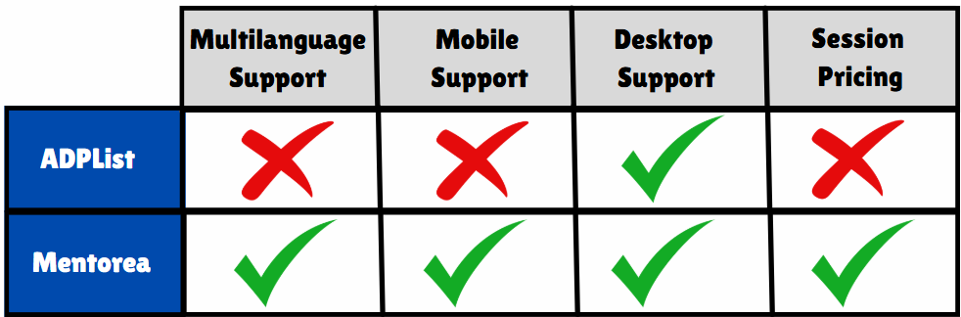

Figure Comparative Table

# 2.9 Conclusion

The shift from traditional to digital mentorship is a natural evolution in today's digital age. While traditional mentorship remains valuable, the benefits of digital platforms—such as increased accessibility, flexibility, and security—make them a viable and necessary alternative. However, for digital mentorship platforms to be truly effective, they must address the challenges of rapport building, technological barriers, and meaningful evaluation.

The **Mentorea Platform** project aims to integrate these essential features while prioritizing security, privacy, and a user-friendly interface. By facilitating secure communication, offering flexible scheduling, and providing data-driven insights, this platform has the potential to revolutionize the mentorship experience and make professional development more accessible to individuals worldwide.

# 

**Chapter 3:**

**Project Management**

# Chapter 3: Project Management

# 3.1 Introduction

Project management is a process that includes planning, putting the project plan into action, and measuring progress and performance. This chapter will discuss the used development methodology in the project, the plan that should be followed to achieve all tasks successfully, and the feasibility study. Project planning is to begin to define the parameters of the project and to establish the appropriate project management and quality environment required to complete the project.

# 3.2 Project Plan

1. **Gathering Requirements**

* **Objective:** Collect all necessary information for project implementation.
* **Tasks:**
* Identify requirements from stakeholders and target users.
* Document functional and non-functional requirements clearly.

1. **System Analysis**

* **Functional & Non-Functional Requirements**:
* **DFD Diagram**: Map out data flow to understand data interactions within the system.
* **Use Case Diagram**: Define usage scenarios and user interactions with the system.
* **UI/UX Design**: Develop interface designs and user experience layout.
* **Machine Learning Feasibility**: Analyze where machine learning can enhance the system.
* **Recommendation System Analysis**: Identify how recommendations will function based on user data.

1. **System Design**

* **Diagrams for Structure and Flow**:
  + **Sequence Diagram**: Outline the sequence of operations across system components.
  + **Class Diagram**: Define objects and interactions within the system.
  + **Activity Diagram**: Detail activities in each process for clarity.
* **Database Design**:
  + **ERD Model**: Create an Entity-Relationship Diagram to organize data structure.
  + **Mapping**: Create a Relational Database Mapping to organize data structure.
* **ML Model Design:**
  + Design architecture for machine learning algorithms.
  + Determine which models will power the recommendation system.

1. **Implementation**

* **Database Development**:
  + Develop the database using **SQL Server**.
* **Back-End Development:**
* Build the backend using
  + **C#**
  + **ASP.NET Core Web API**
  + **Entity Framework Core**
  + **CQRS Pattern** to separate read and write tasks.
  + **Signal R** for real-time communication.
* **Machine Learning:**
  + Implement ML models using appropriate libraries.
  + Train recommendation models on user data for personalized suggestions.
  + Integrate recommendation API into back-end services.
* **Front-End Development:**
* Develop the user interface with
  + **Flutter Framework** using **Dart**
  + **MVVM** for Design Pattern
  + **Bloc (Cubit)** for state management
  + **Shared Preferences** for local data storage
  + **API** to link front-end with back-end
  + **Localization** to support multiple languages
  + **Dark Mode & Light Mode** for theme options.
* **Testing**
* Conduct thorough testing to ensure the system is functional, meets all requirements, and offers a seamless user experience. Testing categories include:
  + **Functional Testing**
  + **Performance Testing**
  + **User Experience Testing**
  + **ML Model Evaluation**: Measure model accuracy and optimize.
  + **Recommendation System Testing**: Validate recommendation relevance and effectiveness.
* **Maintenance**
  + **Bug Fixes & Updates**: Regularly monitor the system for bugs and perform updates as necessary to ensure optimal functionality.
  + **Performance Optimization**: Continuously evaluate system performance and make adjustments to improve efficiency, especially as usage scales.
  + **Database Maintenance**: Implement regular database backups and optimize queries to keep data access smooth and secure.
  + **User Feedback Integration**: Gather and analyze user feedback to identify improvements and add features that enhance the user experience.
  + **Documentation Updates**: Keep all documentation current with any changes, updates, or newly implemented features.

# 3.3 Project Management Activity

* + 1. Project Activities
  1. Setting up schedules for the project and all of its subtasks
  2. Keeping an eye on time usage to ensure optimal effectiveness.
  3. Identifying potential project risks. Creating a risk management strategy to handle undesirable contingencies.
  4. Organizing relevant documents and records so that they may be conveniently consulted by those working on the project.
  5. Examining the project's existing circumstances and forecasting future developments to avoid being caught off guard by changes.
  6. Giving specific individuals or groups short-term assignments and tracking their progress toward fulfillment.
  7. Managing any project-related issues; maintaining an issue log that classifies issues by priority and type.
  8. Meeting the needs of the project's product quality. Ensuring proper quality assurance and control. Finding methods to raise the standard.
     1. Activity Organization
* **Team Structure**: The team operates with an integrated style, where each member has a clearly defined role based on their strengths and expertise. This structure enhances collaboration and ensures efficiency in project execution.
* **Position 1: Team Leader**
* Responsibilities:
* Manages and oversees the project.
* Assigns tasks according to each member’s skills.
* Supports and motivates team members.
* Solves internal issues and guides the team toward achieving project goals.
* **Position 2: Front-End Developer (Flutter)**
* Responsibilities:
* Develops the user interface using Flutter, focusing on an intuitive and user-friendly design.
* Ensures visual consistency in fonts, colors, and layouts.
* Enhances user experience to create an attractive and accessible application.
* **Position 3: Back-End Developer**
* Responsibilities:
* Develops and maintains the server-side of the application.
* Manages APIs and ensures seamless data exchange with the front end.
* Ensures smooth functionality and performance of server-side processes that are invisible to users.
* **Position 4: Machine Learning Engineer**
* Responsibilities:
* Designs and trains machine learning models, with a focus on improving user experience and engagement
* Develops a recommendation system tailored to user preferences and needs.
* Collaborates with the back-end team to integrate ML models into the application.
* **Position 5: Database Administrator**
* Responsibilities:
* Designs, implements, and manages the database structure.
* Maintains database security, performance, and data integrity.
* Coordinates with the back-end team to optimize data storage and retrieval.
* **Position 6: Project Reporter**
* Responsibilities:
* Documents each phase of the project and provides updates on progress.
* Prepares reports for both internal and external stakeholders.
* Ensures that all project steps, changes, and achievements are well-recorded and organized.

# 3.4 Risk Identification

Identifying potential risks is critical for effective project management and execution. By recognizing risks early, the team can develop strategies to minimize their impact and ensure successful project outcomes. The risk identification strategy outlined here complements the team’s current approach, allowing for a more comprehensive risk list to support planning and management. Risk identification is iterative and should involve the entire project team from the outset.

The following are the main risk categories associated with this project:

1. **Scheduling Risk**

* **Potential Issues**:
* The schedule is based on a "best case" scenario, which may not be realistic.
* Some essential tasks have been overlooked in the current schedule.
* Delays in one task can cause cascading delays in other dependent tasks.
* Unfamiliar components take longer to design and implement than initially expected.

1. **Requirements Risk**

* **Potential Issues**:
* Baseline requirements are still evolving and being modified.
* Poorly specified requirements lead to scope creep as further definitions arise.
* Only partial knowledge of initial requirements may affect early planning.
* The development team may be unable to deliver all required features within the specified timeline.

**Risk Identification Process**:

* A variety of tools, methods, and approaches are available for identifying project risks, which will be adapted to suit this project. Involving the entire project team from the start will ensure that risk identification is thorough and effective.

# 3.5 Project Scheduling

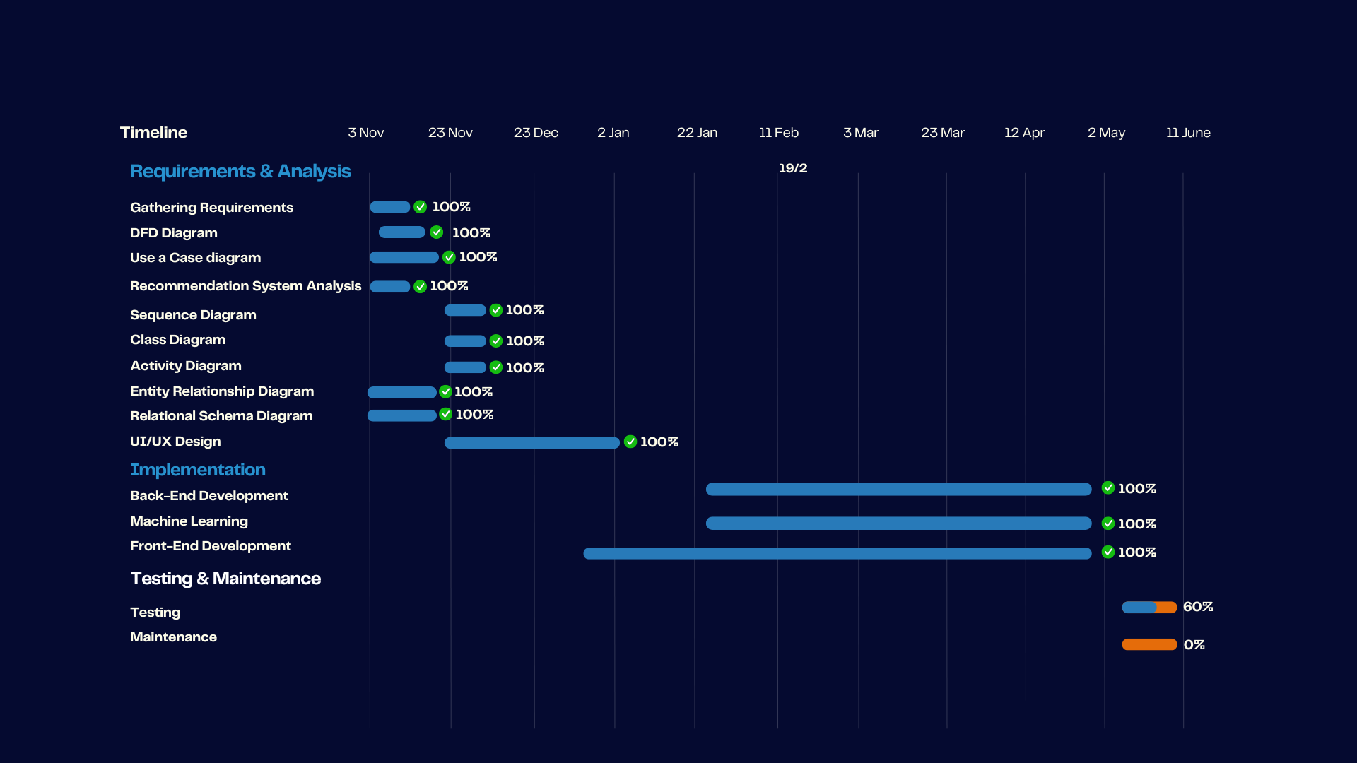

Figure Project Scheduling Gantt Chart

# 

**Chapter 4:**

**System Analysis & Design**

# Chapter 4: System Analysis & Design

# Introduction

The purpose of this system analysis is to understand the requirements and design considerations for the development of **Mentorea**, a mentorship platform that enables effective communication between mentors and mentees. This analysis aims to define the system's scope, functional and non-functional requirements, data flow, and user interactions. It will serve as a foundation for the subsequent stages of system development and implementation.

# System Overview

**Mentorea** is a platform designed to overcome geographic and social barriers in mentorship by connecting mentees with experienced mentors. The platform’s objectives include:

1. Facilitating seamless communication between mentors and mentees through features like chat and video calls.
2. Providing a streamlined process for scheduling mentorship sessions based on availability.
3. Offering mentees the ability to search for mentors based on expertise, ratings, and availability.

**Key Features:**

* **Real-Time Communication**: Chat and video call functionalities powered by Signal R for real-time interaction.
* **Session Scheduling**: A user-friendly interface to book mentorship sessions with conflict validation.
* **Recommendation System**: Machine learning-based mentor recommendations tailored to mentees’ needs.
* **Feedback and Analytics**: Tools to gather session feedback and monitor platform performance for continuous improvement.

By focusing on these features, **Mentorea** ensures that mentors and mentees have a comprehensive and reliable solution for fostering meaningful connections and career development.

# Stakeholder Identification

The primary stakeholders in **Mentorea** include:

1. **Mentees**:
   * **Roles**: Seek guidance from mentors to enhance skills, knowledge, and career opportunities.
   * **Responsibilities**:
     + Search for mentors based on expertise.
     + Schedule mentorship sessions.
     + Provide feedback after sessions.
   * **Expectations**:
     + A user-friendly interface.
     + Access to mentors with relevant expertise.
     + Reliable communication tools.
2. **Mentors**:
   * **Roles**: Provide guidance, share knowledge, and help mentees achieve their goals.
   * **Responsibilities**:
     + Maintain an up-to-date profile.
     + Approve or decline session requests.
     + Deliver mentorship sessions.
   * **Expectations**:
     + Clear session scheduling system.
     + Secure and reliable communication channels.
     + Feedback mechanisms to track performance.
3. **System Administrators**:
   * **Roles**: Oversee platform operations and ensure the system runs smoothly.
   * **Responsibilities**:
     + Manage user registrations and content moderation.
     + Monitor system performance and resolve technical issues.
     + Analyze platform data for improvements.
   * **Expectations**:
     + A robust backend with efficient management tools.
     + Scalable and secure infrastructure.

# 4.4 Stakeholder Identification

System requirements are the essential attributes and features of Mentorea, which describe its desired functionalities and ensure stakeholders' needs are met effectively. These requirements guide system architecture, design, validation, and user acceptance. They are categorized into functional and non-functional requirements.

# 4.4.1 Functional Requirements

The functional requirements define the specific features and capabilities of **Mentorea**, including:

1. **User Registration and Authentication**:
   * Allow mentors and mentees to create accounts and log in using secure authentication methods (e.g., Google Auth).
2. **Session Scheduling**:
   * Enable mentees to view mentors' availability and schedule mentorship sessions.
   * Include conflict validation to prevent double bookings.
   * **Messaging System**:
   * Provide real-time communication between mentors and mentees through chat and video calls (powered by Signal R).
   * Support one-on-one and group messaging.
3. **Recommendation System**:
   * Use a machine learning algorithm to recommend mentors based on mentees' preferences, expertise, and past interactions.
4. **Feedback and Ratings**:
   * Allow mentees to rate and review mentors after sessions.
   * Provide mentors with constructive feedback to improve their services.
5. **Notifications**:
   * Send automated notifications about session bookings, updates, deadlines, and reminders.
6. **Data Management**:
   * Ensure seamless storage and retrieval of user data, session histories, and feedback using SQL Server.

# 4.4.2 Non-Functional Requirements

The non-functional requirements define the quality attributes of **Mentorea**, including:

1. **Performance**:
   * Ensure low latency and high responsiveness for real-time communication.
   * Handle concurrent users without degradation in performance.
2. **Usability**:
   * Provide an intuitive interface for mentors and mentees, catering to varying levels of technical proficiency.
3. **Security**:
   * Implement data encryption (e.g., SSL/TLS) to secure communication.
   * Use access controls and secure authentication to protect user accounts and data.
4. **Reliability**:
   * Minimize downtime and provide consistent availability.
   * Include error-handling mechanisms for common issues, such as connection failures.
5. **Scalability**:
   * Support an increasing number of users and larger data volumes as the platform grows.
   * Enable horizontal scaling of backend services.

# 4.5 User Requirements

# 4.5.1 For Mentor

1. Tools to view and approve session requests from mentees.
2. Ability to provide personalized feedback and ratings after sessions.
3. Access to mentee profiles to understand their goals and preferences.
4. Notifications about upcoming sessions, cancellations, or urgent updates.

# 4.5.2 For Mentee

1. An easy-to-use interface to search for and book mentors.
2. Tools to communicate with mentors through chat or video calls.
3. Ability to receive notifications for upcoming sessions, changes, or feedback.
4. Access to session history and personalized mentor recommendations.

These requirements provide a roadmap for developing a robust and user-centric mentorship platform, ensuring that **Mentorea** meets the needs of all stakeholders effectively.

# 4.6 Use Case Diagram

A **Use Case Diagram** helps visualize the interactions between users (actors) and the system. It captures the system's functionality from the user's perspective, representing the system's processes and how users will interact with them to achieve specific goals.

**Components of a Use Case Diagram:**

1. **Actors**:
   * These are the external entities (users or other systems) that interact with the system. In your **Mentorea** platform, actors can be:
     + **Mentee**: The user seeking mentorship and communication.
     + **Mentor**: The user providing mentorship and expertise.
     + **Admin**: The person managing the platform's activities and settings.
2. **System**:
   * The **Mentorea** platform itself, including its functionalities such as user registration, scheduling sessions, messaging, and feedback submission.
3. **Goals**:
   * These are the objectives or purposes behind each interaction between the users and the system. For example:
     + Mentee searching for a mentor.
     + Mentor accepting or rejecting a session request.
     + Admin managing Mentorea settings and user registrations.

# 

Figure 3 Use Case Diagram

# 4.7 Use Case Analysis

|  |  |  |
| --- | --- | --- |
| **Use case name:** | **Register** | |
| **Actor(s):** | **Mentee and Mentor** | |
| **Description:** | **This use case describes the process of a user registering a new account.** | |
| **Typical Course of Events:** | **Actor Action** | **System Response** |
| **Step1: The user clicks on the Register button and enters his information and click register.** | **Step2: The system checks the validation of entered data.**  **Step3: The system sends the data to database.**  **Step4: The system sends an alert to the user to notify him with the success/failure of registration.** |
| **Preconditions:** | **None.** | |
| **Postconditions:** | **The user has been registered.** | |

Figure 4 Use Case Scenario : SignUp

|  |  |  |
| --- | --- | --- |
| **Use case name:** | **Login** | |
| **Actor(s):** | **Mentee and Mentor** | |
| **Description:** | **This use case describes the process of a user logging into his account.** | |
| **Typical Course of Events:** | **Actor Action** | **System Response** |
| **Step1: The user enters his information and click login** | **Step2: The system checks the validation of entered data.**  **Step3: The system navigates the user to home page.** |
| **Alternate flow of Events:** | **Step3: In case of entering wrong data, the system notifies the user with error or the user has a connection issue.** | |
| **Preconditions:** | **The user has been logged in.** | |
| **Postconditions:** | **The user has been logged in.** | |

Figure 5 Use Case Scenario : Login

|  |  |  |
| --- | --- | --- |
| **Use case name:** | **Manage Profile** | |
| **Actor(s):** | **Mentee and Mentor** | |
| **Description:** | **This use case allows mentee and mentors to create, update, and manage their profiles. It ensures that accurate and up-to-date information is maintained for smooth platform operation.** | |
| **Typical Course of Events:** | **Actor Action** | **System Response** |
| **Step1: The user navigates to the "Profile" section.**  **Step2: The user views their profile details.**  **Step3: The user clicks on "Edit Profile" to update personal information.**  **Step6: The user submits the updated profile.** | **Step4: The system validates the inputs.**  **Step7: The system saves the changes and displays a confirmation message.** |
| **Alternate flow of Events:** | **Step5:** **If the user enters invalid or incomplete data (e.g., missing fields), the system highlights errors and prompts for corrections.** | |
| **Preconditions:** | **- The user has an account on the platform.**  **- The user has logged into the platform.** | |
| **Postconditions:** | **The user's updated profile information is stored in the system and reflected in their account.** | |

Figure 6 Use Case Scenario : Profile Management

|  |  |  |
| --- | --- | --- |
| **Use case name:** | **Navigate Mentors** | |
| **Actor(s):** | **Mentee** | |
| **Description:** | **This use case describes the process by which a mentee searches for mentors based on specific criteria such as expertise, location, ratings, field or availability.** | |
| **Typical Course of Events:** | **Actor Action** | **System Response** |
| **Step1: The mentee navigates to the "Explore" section on the platform.**  **Step3: The mentee filters mentors using specific criteria like expertise, availability, or rating.**  **Step5: The mentee can also search about specific mentor ex.(name or field) by the search bar.**  **Step6: The mentee clicks on a mentor's profile for more details.** | **Step2: The system displays a categorized list of mentors**  **Step4: The system updates the list dynamically based on the selected filters.**  **Step7:** **The system displays the mentor's profile with details like experience, availability, and reviews.** |
| **Alternate flow of Events:** | **If no mentors match the search criteria, the system displays a message indicating no results found.** | |
| **Preconditions:** | **-The mentee has an active account on the platform.**  **-The mentee has successfully logged into the platform.** | |
| **Postconditions:** | **-The mentee successfully identifies a mentor they are interested in connecting with.**  **-The mentee can proceed to view the mentor's profile or book a session.** | |

Figure Use Case Scenario : Navigate Mentors

|  |  |  |
| --- | --- | --- |
| **Use case name:** | **Communicate with Real-Time Communication** | |
| **Actor(s):** | **Mentee and Mentor** | |
| **Description:** | **This use case describes the process by which a mentor and mentee communicate with each other in real-time through the platform, either via chat, audio, or video calls.** | |
| **Typical Course of Events:** | **Actor Action** | **System Response** |
| **Step1: The mentee initiates a communication session by clicking on the "Start Session" button.**  **Step3: The mentor accepts the communication request.**  **Step5: Both users engage in a conversation.** | **Step2: The system sends a notification to the mentor indicating the mentee's request for communication.**  **Step4: The system establishes a real-time connection between the mentor and mentee through the selected medium (chat, audio, or video).**  **Step6:** **Once the conversation is complete, either user can terminate the session by clicking the "End Session" button.** |
| **Alternate flow of Events:** | **If the mentee faces technical issues (e.g., poor internet), the system provides troubleshooting steps and allows the session to be resumed once the issue is resolved.** | |
| **Preconditions:** | **- Both mentor and mentee have active accounts on the platform.**  **- The mentee has booked a session with the mentor or initiated a conversation.**  **- Both users are online and available for communication.** | |
| **Postconditions:** | **-** **Mentor and mentee successfully complete their communication session.**  **The system saves a record of the communication for future reference or billing purposes.** | |

Figure Use Case Scenario : Real-Time Communication

|  |  |  |
| --- | --- | --- |
| **Use case name:** | **Book Session** | |
| **Actor(s):** | **Mentee** | |
| **Description:** | **This use case describes the process by which a mentee books a session with a mentor on the platform.** | |
| **Typical Course of Events:** | **Actor Action** | **System Response** |
| **Step1: The mentee searches for a mentor or selects one from their recommendations.**  **Step2: The mentee views the mentor’s profile, including their availability and session details.**  **Step3:** **The mentee selects an available time slot for the session.**  **Step5: The mentee confirms the booking by clicking the "Book Now" button.** | **Step4: The system displays session details, including duration, cost, and any additional terms.**  **Step6:** **The system sends a booking confirmation notification to both the mentee and mentor.**    **Step7: After both parties agree and confirm, If payment is required, the system processes the payment using the mentee’s selected method.** |
| **Alternate flow of Events:** | **If the mentee wishes to reschedule before confirmation, they can return to the mentor’s profile and select a different time slot.** | |
| **Preconditions:** | **- The mentee has an active account and is logged into the platform.**  **- The mentee has sufficient funds (if required) or an active subscription.**  **- The mentor's availability is displayed on the platform.** | |
| **Postconditions:** | **- The session is successfully booked, and the mentee and mentor receive notifications.**  **- The session details are saved in the mentee ’s and mentor’s dashboards for future reference or billing purposes.** | |

Figure Use Case Scenario : Book Session

|  |  |  |
| --- | --- | --- |
| **Use case name:** | **Participate in the Community** | |
| **Actor(s):** | **Mentee and Mentor** | |
| **Description:** | **This use case describes how users (mentors and mentees) engage in the community section of the platform by posting content and participating in discussions.** | |
| **Typical Course of Events:** | **Actor Action** | **System Response** |
| **Step1: The user navigates to the "Community" section of the platform.**  **Step2: The user views existing discussions, posts, or questions within the community.**  **Step3:** **The user participates by:**  **- Posting a new question, discussion topic, or content.**  **- Responding to an existing post or providing an answer to a question.** | **Step4: The system validates the content for appropriateness (e.g., no offensive language) before publishing.**  **Step5:**  **The system updates the community feed with the user’s post or response.** |
| **Alternate flow of Events:** | **- If the system detects inappropriate content, the post is flagged and not published.** | |
| **Preconditions:** | **- The user (mentor or mentee) has an active account and is logged into the platform.**  **- The community section is accessible on the platform interface.**  **- The user agrees to community guidelines.** | |
| **Postconditions:** | **- The user’s participation (e.g., post, comment, or response) is visible to the community.**  **- The community feed is updated with new contributions, encouraging engagement.** | |

Figure Use Case Scenario : Participate in the Community

|  |  |  |
| --- | --- | --- |
| **Use case name:** | **Give Feedback on Session** | |
| **Actor(s):** | **Mentee** | |
| **Description:** | **This use case describes how mentees provide feedback on completed sessions to improve the experience and offer constructive insights.** | |
| **Typical Course of Events:** | **Actor Action** | **System Response** |
| **Step2: The user fills out a feedback form, which includes:**  **Ratings (e.g., 1–5 stars or similar).**  **Optional comments about the session.**  **Step3: The user submits the feedback form.** | **Step1: After the session, the system prompts the mentee to provide feedback**  **Step4:**  **The system saves the feedback, updates session records, and optionally notifies the other party about the feedback received.** |
| **Alternate flow of Events:** | **-**  **If the user chooses not to provide feedback, the system marks the session as completed without feedback.** | |
| **Preconditions:** | **- The session has been completed.**  **- Both the mentee have active account on the platform.**  **- Feedback functionality is available in the system.** | |
| **Postconditions:** | **- The feedback is successfully stored in the system and linked to the session record.**  **- The platform aggregates feedback to improve mentor/mentee profiles and platform analytics.** | |

Figure Use Case Scenario : Session Feedback

|  |  |  |
| --- | --- | --- |
| **Use case name:** | **Receive Money** | |
| **Actor(s):** | **Mentor** | |
| **Description:** | **This use case describes how mentors receive payments for their completed sessions through the platform’s payment system.** | |
| **Typical Course of Events:** | **Actor Action** | **System Response** |
| **Step1: The mentor logs into their account and navigates to the "Earnings" or "Payments" section.**  **Step3: The mentor initiates a withdrawal request by clicking the "Withdraw" button.**  **Step5:** **The mentor confirms the withdrawal request.**  **Step7: The mentor receives the funds in their selected payment method.** | **Step2: The system displays the mentor’s total earnings, pending payments, and available balance.**  **Step4:**  **The system prompts the mentor to select a withdrawal method (e.g., bank transfer, e-wallet).**  **Step6: The system processes the withdrawal and displays a confirmation message.** |
| **Preconditions:** | **- The mentor has completed at least one session for which payment is due.**  **- The mentor has linked a valid payment method (e.g., bank account, e-wallet) to their account.**  **- The platform has processed the mentee’s payment for the session.** | |
| **Postconditions:** | **- The mentor successfully receives the requested amount in their chosen payment method.**  **- The mentor’s platform balance is updated to reflect the withdrawal.** | |

Figure Use Case Scenario :Receive Money

|  |  |  |
| --- | --- | --- |
| **Use case name:** | **Manage Platform** | |
| **Actor(s):** | **Admin** | |
| **Description:** | **This use case describes how admins manage and oversee platform operations, including user accounts, content moderation, and system functionality, to ensure a smooth and secure experience for mentors and mentees.** | |
| **Typical Course of Events:** | **Actor Action** | **System Response** |
| **Step1: The admin navigates to the management dashboard.**  **Step2: The admin performs one or more platform management tasks, such as:**  **- Monitoring platform activity for compliance with community guidelines.**  **- Moderating flagged content or resolving disputes between users.**  **- Managing platform settings, such as session rates or available features.**  **- Reviewing platform analytics, including user engagement and performance metrics.** | **Step3: The system updates platform records based on the admin’s actions.** |
| **Preconditions:** | **-The admin has valid credentials to access the platform’s management dashboard.**  **-The platform is functional and accessible to users.** | |
| **Postconditions:** | **- The platform is updated and maintained according to the admin’s actions.**  **- User accounts, content, and system settings comply with platform policies.** | |

Figure Use Case Scenario : Manage Platform

|  |  |  |
| --- | --- | --- |
| **Use case name:** | **Manage Mentor Work** | |
| **Actor(s):** | **Mentor** | |
| **Description:** | **This use case allows mentors to manage their work by setting session time slots and accessing session statistics, such as the number of sessions conducted, total minutes spent, and ratings received for each session.** | |
| **Typical Course of Events:** | **Actor Action** | **System Response** |
| **Step 1: The mentor navigates to the "Manage Work" section.**  **Step 3:** **The mentor selects "Set Session Time Slots."**  **Step5: The mentor enters the time slots and submits them.**  **Step 7:** **The mentor selects "Access Session Statistics."** | **Step2: The system displays options for managing sessions and viewing statistics.**  **Step4: The system prompts the mentor to input available time slots.**  **Step6: The system validates the input and updates the mentor's availability.**  **Step8: The system displays session statistics, including the total number of sessions conducted, total minutes spent, and ratings for each session.** |
| **Preconditions:** | **-** **The mentor has logged into the platform.**  **- The mentor has an active profile.** | |
| **Postconditions:** | **- The mentor's updated availability is reflected on the platform.**  **- The mentor can view up-to-date session statistics for better performance tracking.** | |

Figure Use Case Scenario : Manage Platform

# 4.8 Activity Diagram

An **Activity Diagram** is a UML diagram that visually represents the flow of activities in a system. It illustrates the sequence of actions, decisions, and workflows, showing where the process starts, what actions are performed, where decisions are made, and where the process ends.

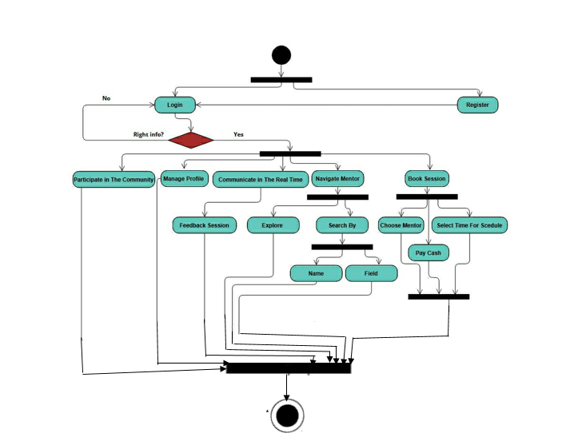

Figure Activity Diagram : Mentee

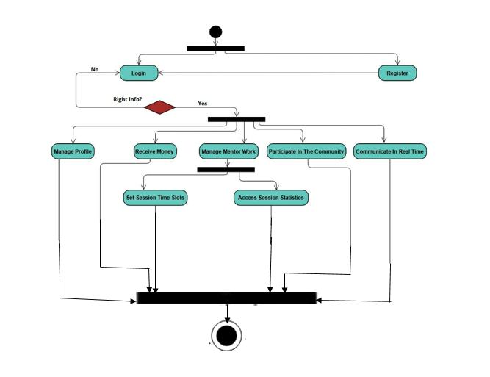

Figure Activity Diagram : Mentor

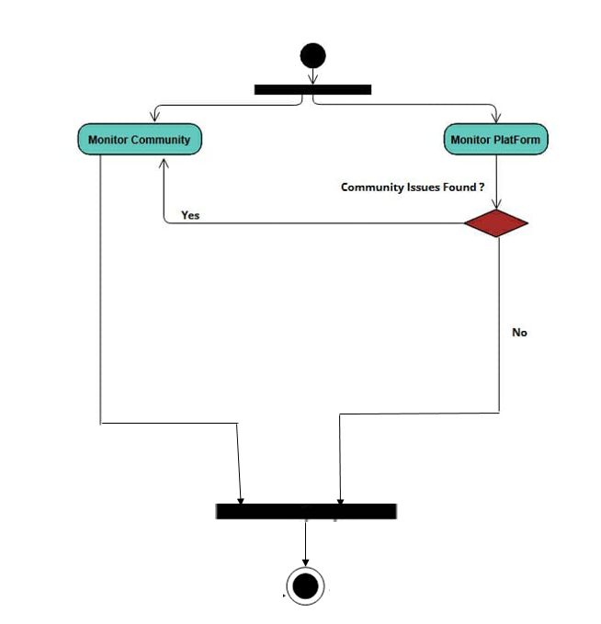

Figure Activity Diagram : Admin

# 4. 9 System Sequence Diagram

A **System Sequence Diagram (SSD)** is a UML diagram that visually represents the flow of interactions between external actors and the system. It focuses on the events exchanged between users (actors) and the system for a specific use case, treating the system as a "black box" to emphasize the external events.

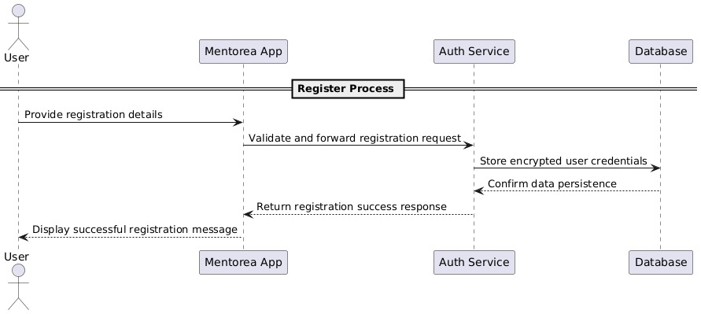

Figure Sequence Diagram : Register

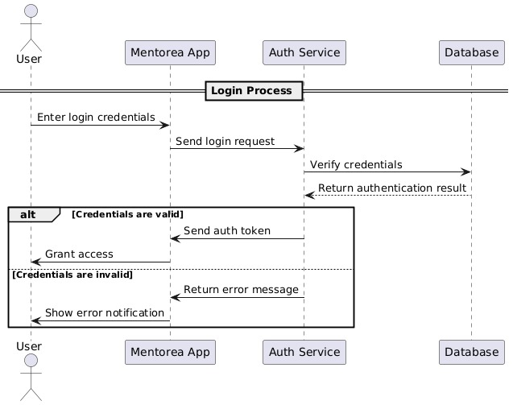

Figure Sequence Diagram : Login

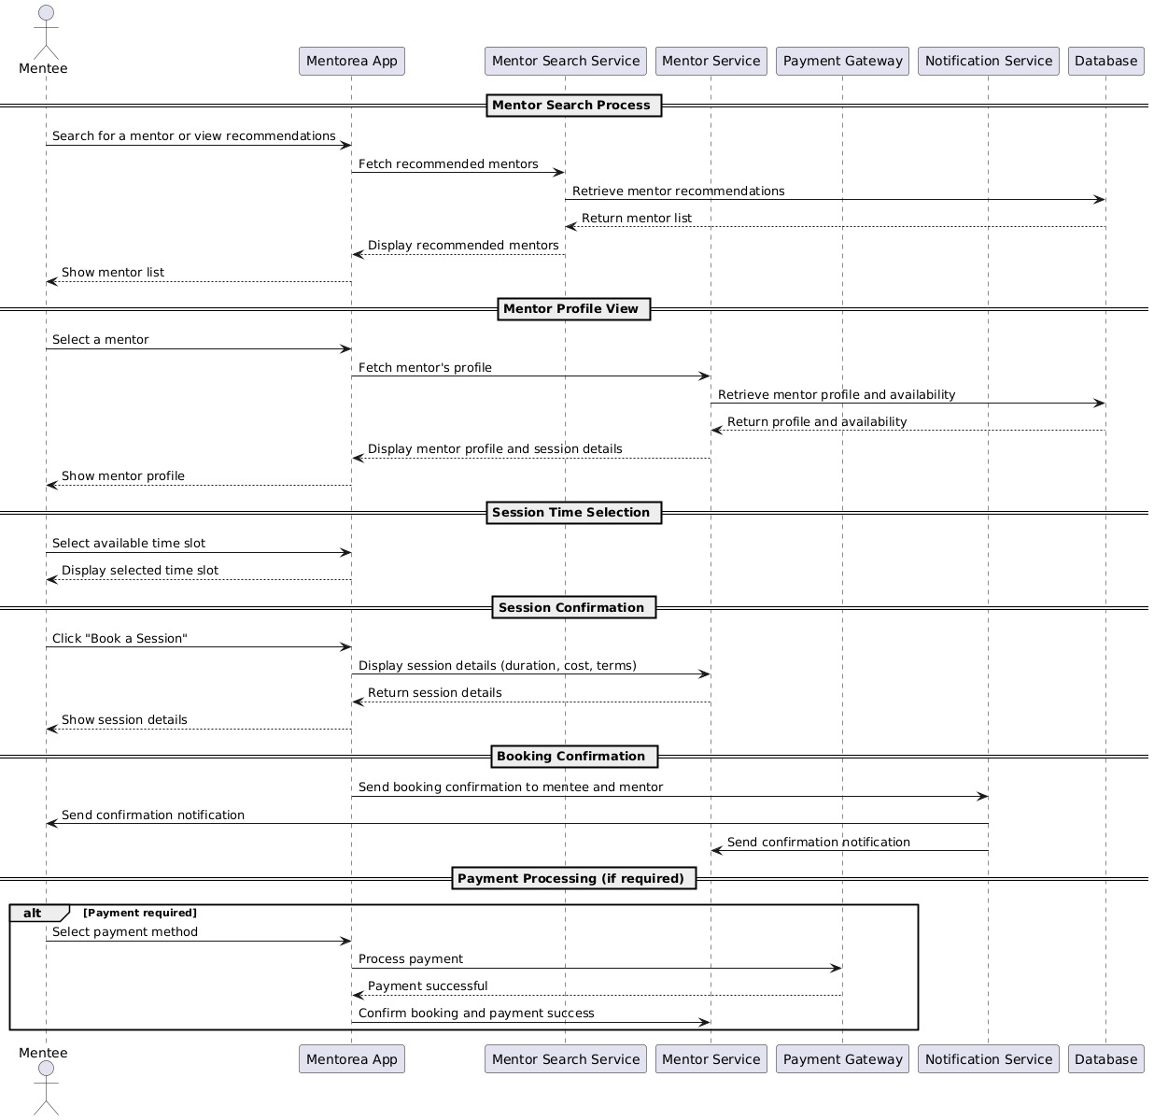

Figure Sequence Diagram : Mentee Activities

# 4.10 Class Diagram

A **Class Diagram** is a type of UML diagram that represents the static structure of a system. It shows the system's classes, their attributes, methods (operations), and the relationships between them. This diagram is essential in object-oriented design and is used as a blueprint for implementing the system.

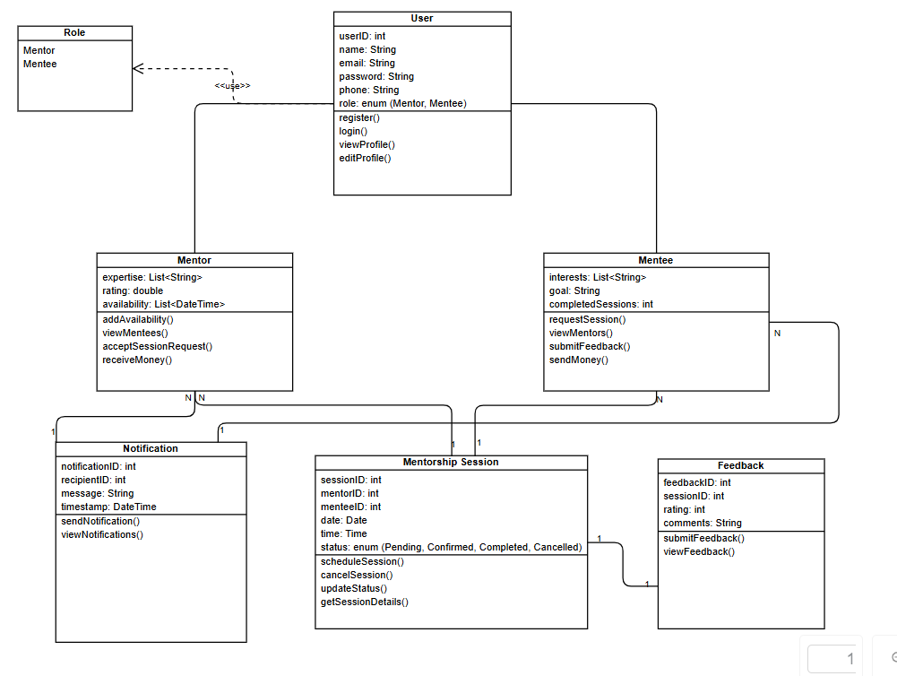

Figure Class Diagram

# 4.11 Data Flow Analysis

Data flow analysis focuses on understanding how data moves through the system, the processes that manipulate this data, and the outputs that result. For Mentorea, the data flows involve several core entities, including user profiles, session bookings, messages, feedback, and other system-related data.

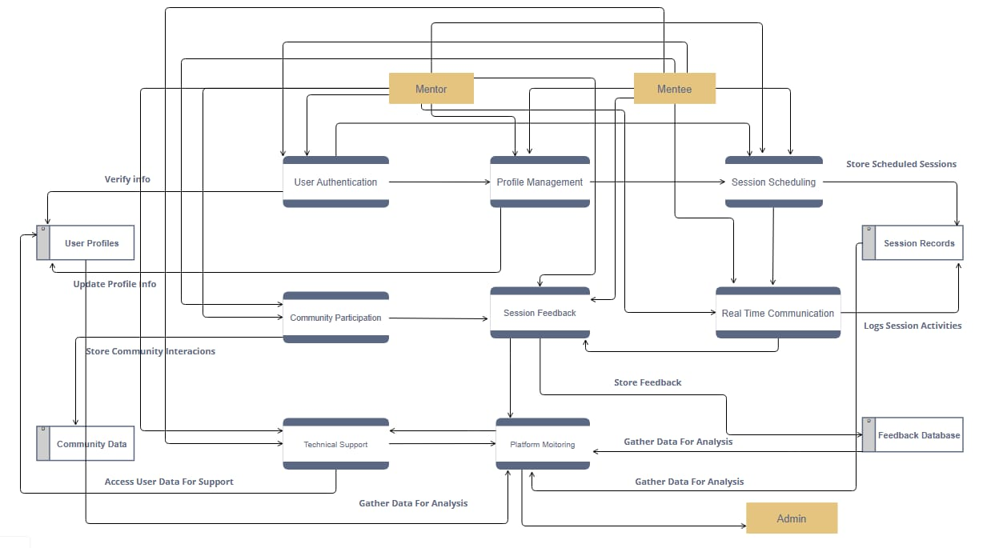

Figure Data Flow Diagram

# 4.12 Entity Relationship Diagram (ERD)

An **Entity-Relationship Diagram (ERD)** visually represents the entities in a system and their relationships. It is widely used in database design to model the logical structure and organization of data.

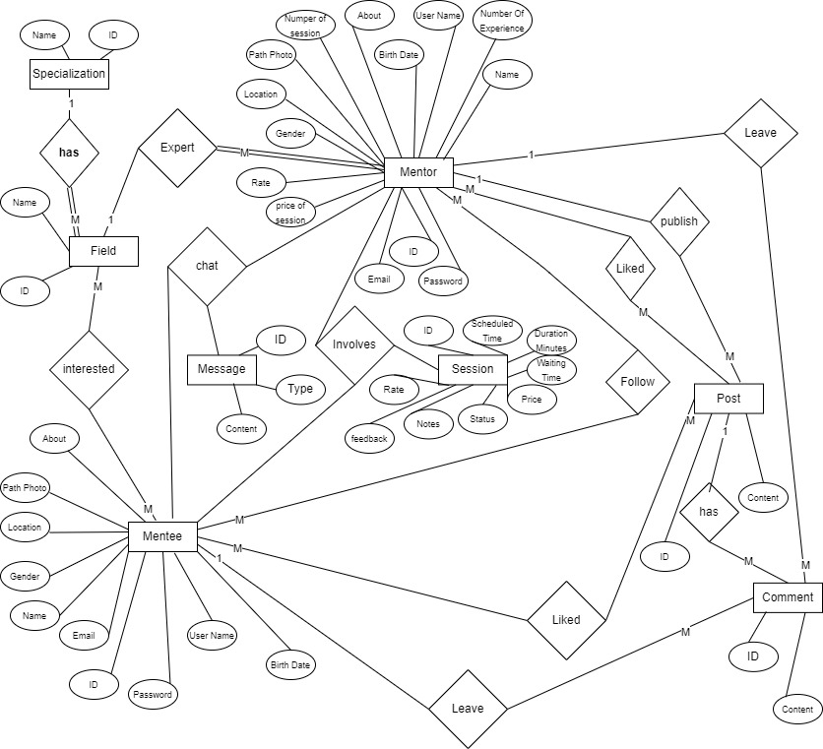

Figure Entity Relationship Diagram

# 4.13 Relational Database Mapping

Mapping from an ERD to **a relational database structure** involves converting entities, attributes, and relationships into tables, columns, and constraints.

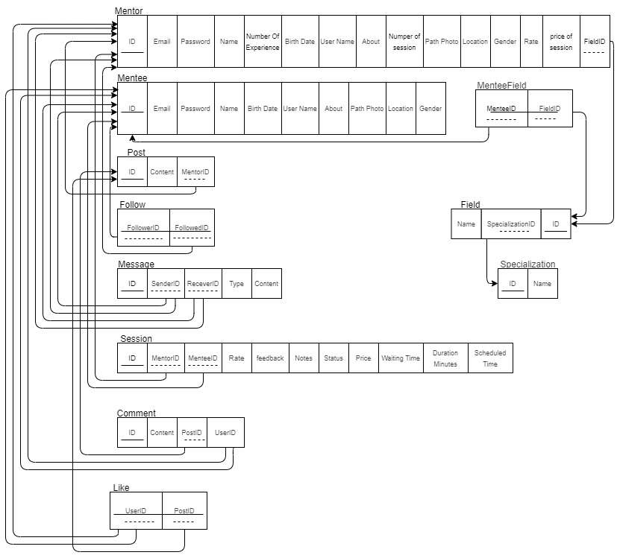

Figure Relation Database Mapping

# 4.14 Artificial intelligence (AI)

In the modern digital age, artificial intelligence (AI) plays a crucial role in enhancing personalized experiences across various domains, including education and mentorship. This chapter explores the integration of AI-powered recommendation systems, sentiment analysis and generative ai within **Mentorea**, our mentorship platform.

**Recommendation system** helps match mentees with the most suitable mentors based on various factors such as expertise, interests, and past interactions. By leveraging machine learning and deep learning techniques, we ensure that users receive personalized suggestions that improve their learning journey.

**Sentiment analysis** enables us to understand mentee and user emotions and feedback by analyzing textual data from session feedback, reviews, and interactions. This allows Mentorea to gauge user satisfaction, detect potential issues, rerating mentors and enhance communication between mentors and mentees.

**Generative AI** further elevates the platform by dynamically creating personalized content. Can generate quick tutorial videos, to make mentee more eager to learn.

Additionally, deep learning techniques enhance both recommendation and sentiment analysis models, making them more efficient and adaptable. By implementing these AI-driven solutions, Mentoria ensures a seamless and engaging learning experience, fostering meaningful connections between mentors and learners.

**4.14.1** **Recommendation System**

**4.14.1.1 Definition**

A recommendation system is an application that predicts what a user might prefer next. It does this by analyzing past behaviors, preferences, or even the behavior of similar users. this's to enhance the user experience by presenting options that are relevant, thereby saving users time and helping them make informed decisions.

**4.14.1.2** **Recommendation Systems Approaches**

* **Absolute ⇒ Simple:** - Recommend an item based on its own popularity, regardless of the user.
* **Content based:** - Based on Meta data.  
   - Based on history of the user preferences.  
   - Not taking advantage of other users’ similarity**.**
* **Collaborative:** - takes advantage of similar users’ history.  
   - in addition to the same user past preferences, to recommend new items.
* **Hybrid Approaches:**Combining both collaborative and content-based filtering to overcome limitations of each method and provide more accurate recommendations.

**Which Approach will be used?**

* Simple Approach at Recommender case at Home Page when user will login.
* Hybrid Approach for mentee at Home Page, Navigate Mentors and Navigate Track/Field.

**4.14.1.3 How Recommendation Systems Work**

* Collect Data
* Data Preprocessing
* Use Approach (Hybrid)
* Prediction & Ranking
* Generate Recommendations
* User feedback again

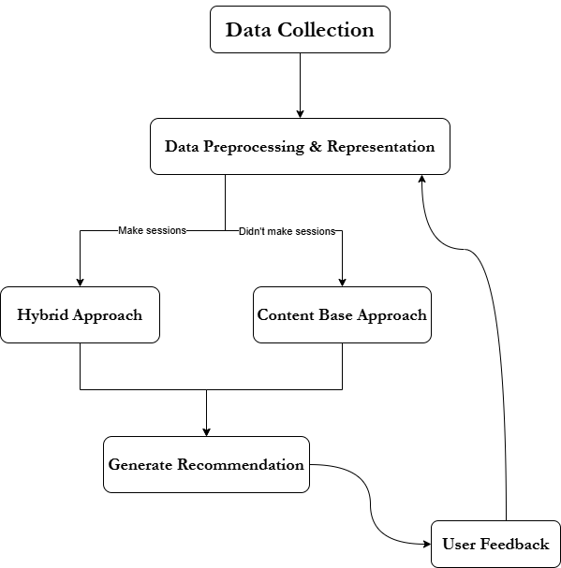

**4.14.1.4** **Recommendation Systems Tools**

**Here’s a list of popular tools and libraries for recommendation systems:**

**Python Libraries**

1. **Surprise:**
   * Focus: Collaborative filtering.
   * Pros: Easy to use, supports basic algorithms like SVD and KNN.
   * Cons: Limited to collaborative filtering; no support for hybrid or content-based methods.
2. **LightFM:**
   * Focus: Hybrid recommendation (collaborative + content-based).
   * Pros: Supports both user-item interactions and metadata (user/item features).
   * Cons: Requires more effort to preprocess data.
3. **TensorFlow/PyTorch:**
   * Focus: Deep learning-based recommendations.
   * Pros: Highly customizable, supports advanced models like Neural Collaborative Filtering (NCF).
   * Cons: Steeper learning curve; requires more computational resources.
4. **Implicit:**
   * Focus: Collaborative filtering for implicit feedback (e.g., clicks, views).
   * Pros: Fast and efficient for large datasets.
   * Cons: Limited to implicit feedback; no support for metadata.

**Frameworks and Platforms**

1. **Apache Spark MLlib:**
   * Focus: Scalable machine learning for big data.
   * Pros: Handles large datasets; supports collaborative filtering.
   * Cons: Requires a Spark cluster; more complex to set up.
2. **Amazon Personalize:**
   * Focus: Managed service for recommendation systems.
   * Pros: No coding required; scalable and production ready.
   * Cons: Limited customization; can be expensive.

**So, will use “LightFM” because it the best for our case, also can use some of “Deep learning” to improvement.**

**4.14.2** **Sentiment analysis**

known as opinion mining used to determine the emotional tone behind a piece of text. It helps in identifying whether the sentiment expressed is positive, negative, or neutral. Some advanced models also classify emotions like joy, anger, sadness, etc.

**4.14.2.1** **How It Works**

1. **Text Processing** – Cleaning the text (removing stopwords, punctuation, etc.).
2. **Feature Extraction** – Converting text into numerical data using techniques like TF-IDF, word embeddings, or bag-of-words.
3. **Sentiment Classification** – Using deep learning (e.g., LSTMs, transformers like **BERT**) to categorize sentiment.

**4.14.2.2 Why use it**

* To make automated Customer Feedback Analysis
* Rerating mentor by session feedback (Mentor Availability)

**4.14.2.3** **Sentiment analysis tools**

**Using NLP tools and libraries like**

* **Keras**: A deep learning framework that enables building neural networks, such as LSTMs and Transformers, for NLP applications like text generation and sentiment analysis.
* **NLTK**: A powerful toolkit for text processing, offering tokenization, stemming, lemmatization, and sentiment analysis tools.
* **Spacy**: An efficient NLP library with pre-trained models for named entity recognition, dependency parsing, and text classification.

**4.14.3** **Generative AI**

Generative AI is the biggest trend in AI today! With the rise of models like ChatGPT, DeepSeak, Stable Diffusion, and Gemini, generative AI is transforming industries by enabling "automation", "creativity", and "personalization". Companies are integrating it into products for content creation, chatbots.

**Generative AI Tools & Technologies**

**1. Large Language Models (LLMs)**

* **GPT (ChatGPT, GPT-4, Gemini)** – Generates human-like text for chatbots, content writing, and coding.
* **LLaMA (Meta AI)** – Open-source LLM for research and development.

**2. AI Development Frameworks & Technologies**

* **TensorFlow & PyTorch** Deep learning frameworks for training generative AI models.
* **Hugging Face** is an AI company and an open-source platform that provides pre-trained machine learning models for tasks like natural language processing (NLP), computer vision, and generative AI.
  + - **Transformers:** Pre-trained models and tools for NLP and generative AI.
    - **Diffusers:** Library for working with diffusion models like Stable Diffusion.
    - **APIs & Cloud Services:** Easy deployment of AI models without heavy infrastructure.

**Our focus will be on “LLMs & Hugging Face”**

* To make something like “Sentiment Analysis”
* Using them to develop the platform.

**Chapter 5:**

**Implementation**

5.1 Introduction

In the previous chapters, we outlined the theoretical foundation of Mentorea, covering the Analysis and Design phases. Now, we transition to the practical implementation of the system.

Implementation involves transforming technical specifications and algorithms into functional software components through programming and deployment. This chapter provides an in-depth look into the technical aspects of developing the core functionalities discussed earlier. At this stage, Mentorea will be brought to life as a mobile application, allowing users to seamlessly access mentorship services from their smartphones.

During this phase, the project becomes tangible and visible to external stakeholders, who may perceive it as just beginning. However, implementation is the execution phase, requiring sustained momentum and adaptability to ensure smooth development.

It is important to acknowledge that achieving a final product that aligns perfectly with the initial requirements is rarely feasible. Unforeseen challenges, evolving insights, and technological advancements may necessitate deviations from the original specifications or design documents. These adjustments, while essential for refining the platform, can sometimes lead to potential conflicts, especially when working with external stakeholders or investors.

To mitigate such challenges, Mentorea remains committed to maintaining transparency, aligning development with stakeholder expectations, and ensuring that all modifications adhere to the foundational agreements established during the definition phase.

# 5.2 Mentorea Main Functions

## 5.2.1 Functions for Mentors:

* Connect with mentees globally, regardless of location.
* Earn additional income through mentorship sessions.
* Communicate with mentees via secure chat, video and audio.

## 5.2.2 Functions for Mentees:

* Access a diverse pool of mentors across various fields.
* Schedule and manage mentorship sessions flexibly.
* Rate mentors based on session quality and experience.
* Engage in secure and private communication with mentors.
* Receive personalized guidance and learning materials.

# 5.3 UI design in Figma

## 5.3.1 Application Screenshots for UI

UI design in Figma involves creating the visual elements of a User interface for

mobile applications to be implemented. This section will show the design



Figure Splash Screen

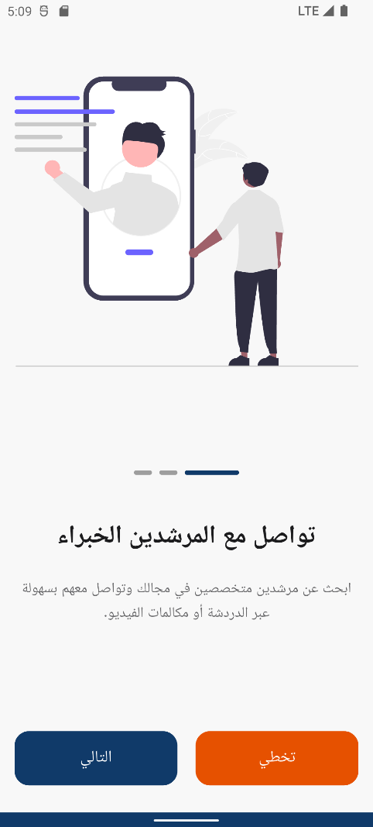

Figure Onboarding

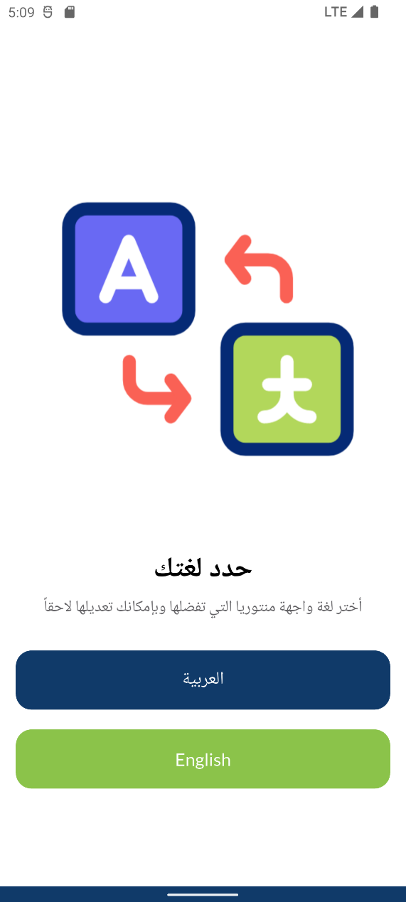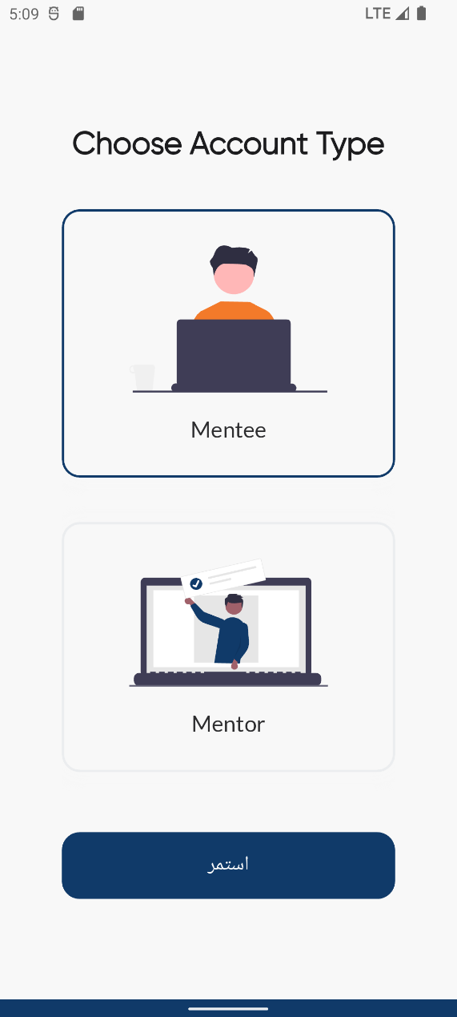

Figure Language Selection Figure Account Type Selection

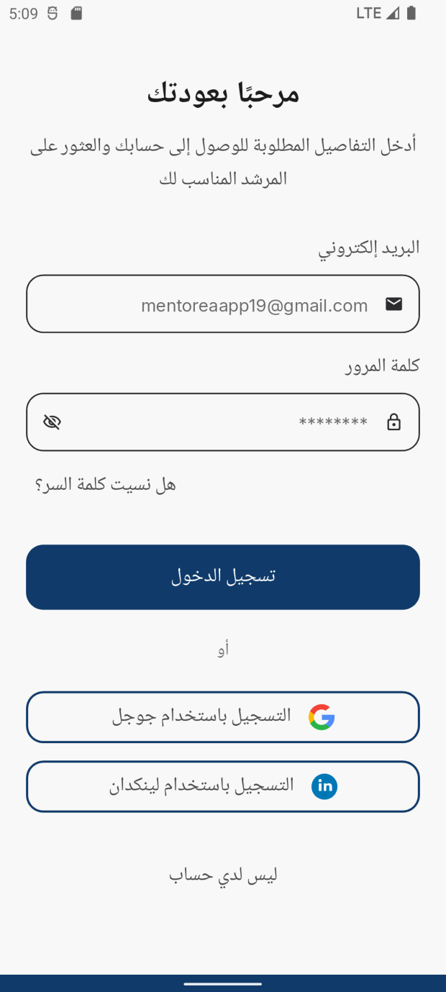

Figure Forget Password Figure Login

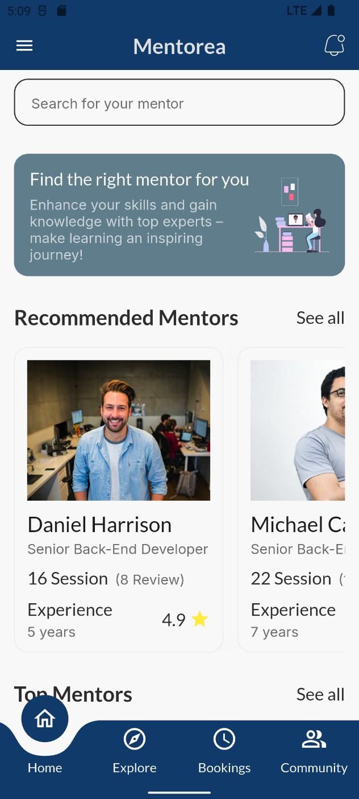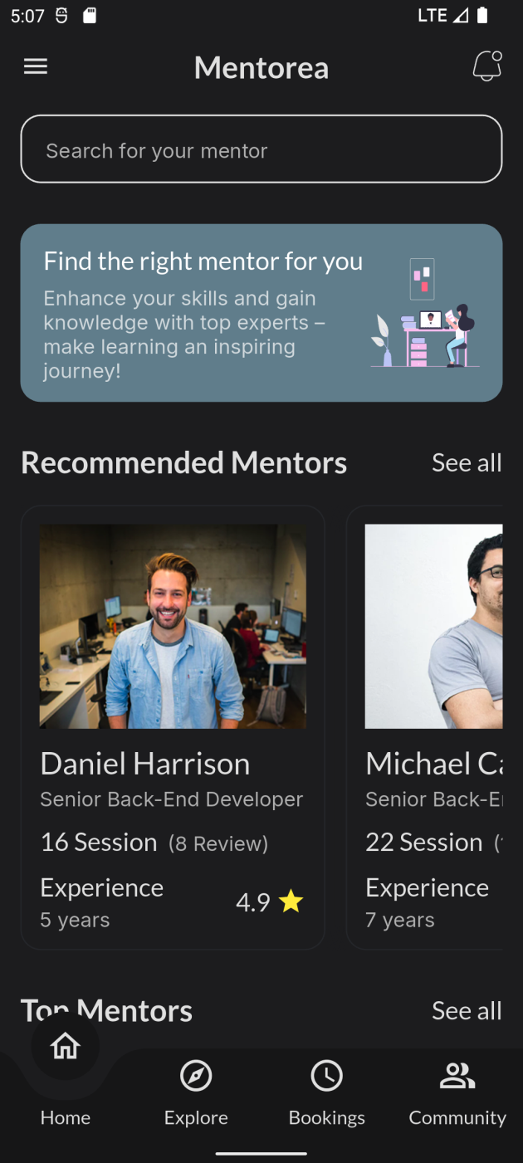

Figure Home (Light Theme) Figure Home (Dark Theme)

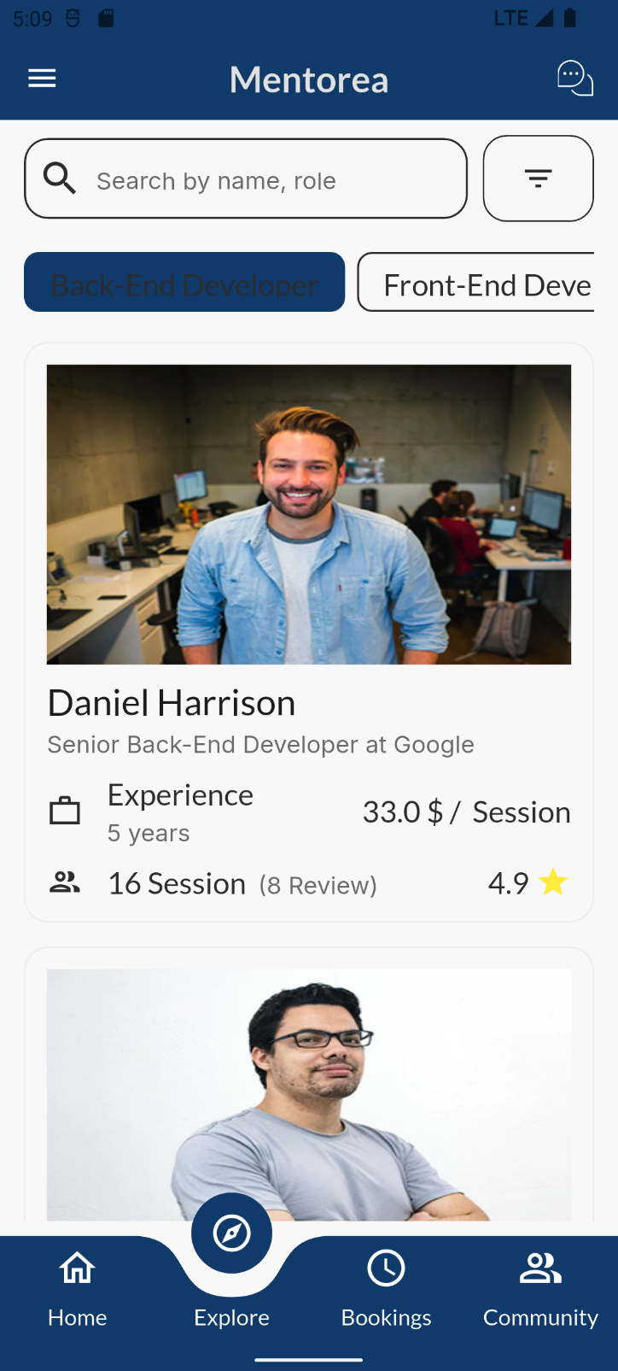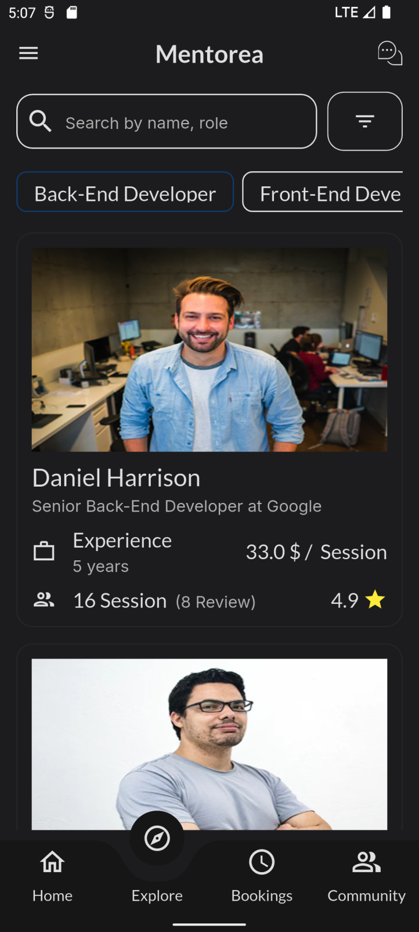

Figure Explore (Light Theme) Figure Explore (Dark Theme)



Figure Settings (Dark Theme) Figure Settings (Light Theme)

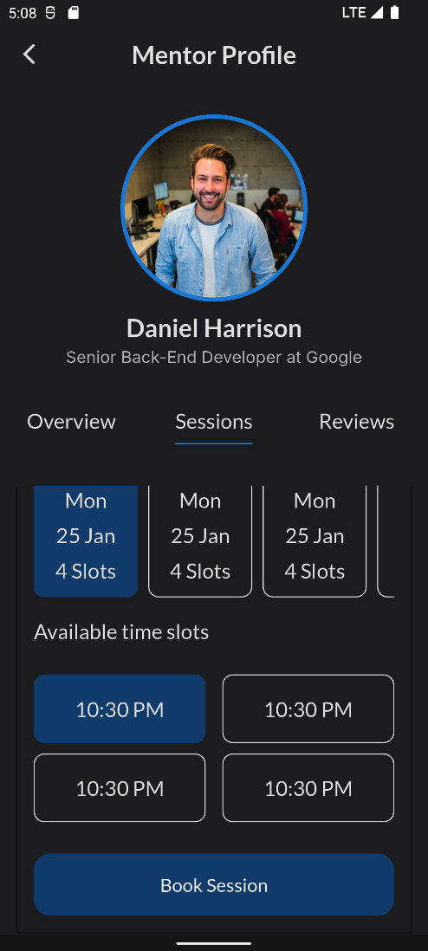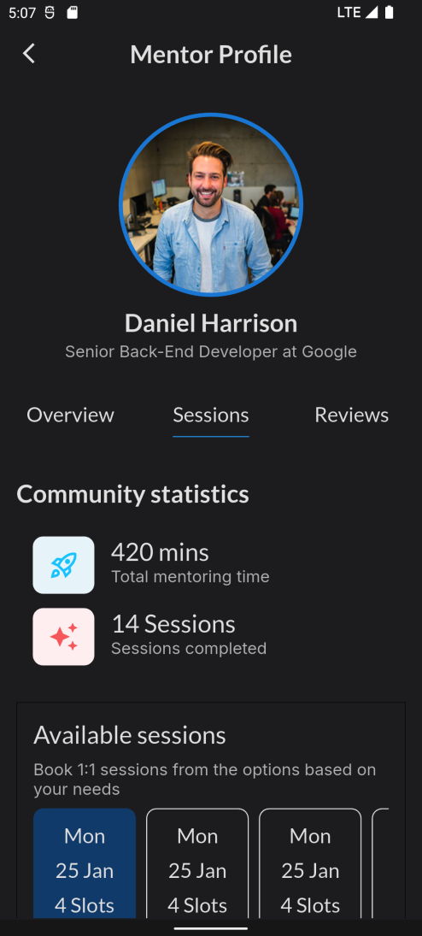

Figure Mentor profile (Mentee perspective)

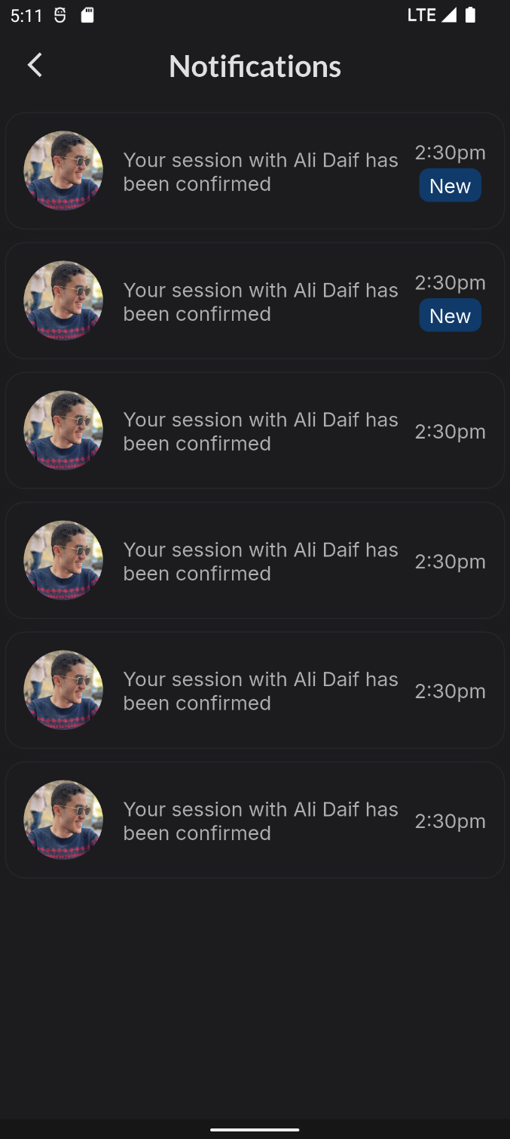

Figure Notification

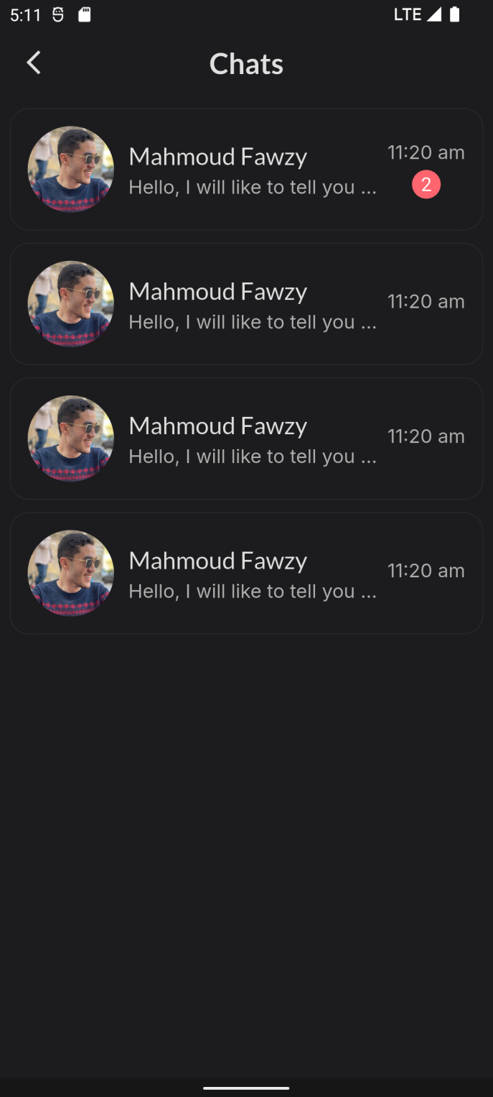

Figure Chats

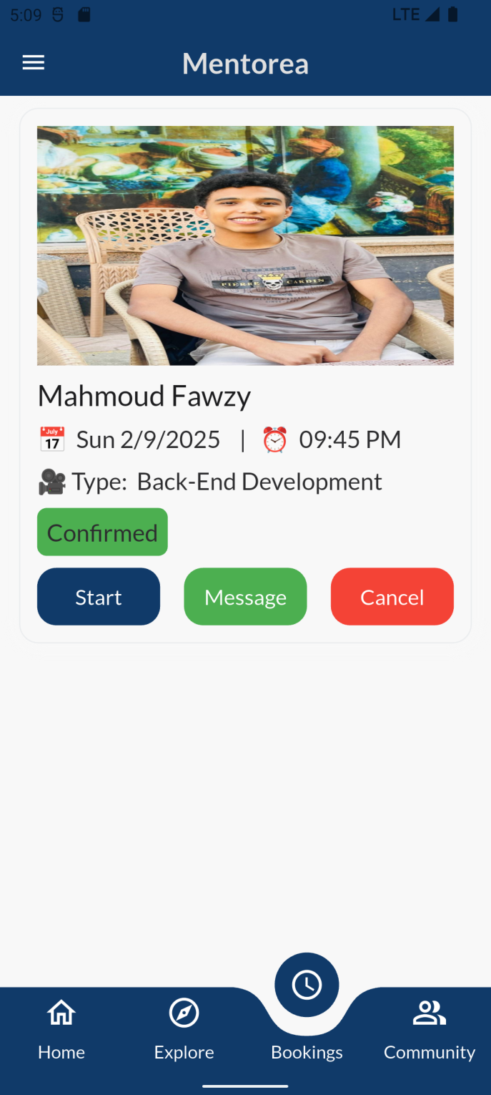

Figure Payment Method selection Figure Bookings

# 5.4 Mobile application implementation

In This, Section 5.3, the UI design and implementation of screens were achieved using Dart and Flutter frameworks, following the MVVM (Model-View-ViewModel) architecture, with the aid of VS Code. This approach brings several benefits:

* **Code Readability and Maintenance:** Flutter’s declarative UI and Dart’s clean syntax reduce boilerplate and make the codebase easy to read and maintain. In MVVM, the ViewModel encapsulates handlers and state logic, allowing the UI (View) to remain simple and focused solely on presentation.
* **Separation of Concerns:** MVVM clearly divides responsibilities between Model, ViewModel, and View. Business logic and event handling live in the ViewModel. This separation improves scalability, testability, and team collaboration.
* **Reactive UI with State Management:** Flutter’s declarative UI and Dart’s concise syntax reduce boilerplate. This improves code readability and eases long-term maintenance. MVVM separates logic into the ViewModel, keeping the UI clean and focused.
* **Lifecycle Awareness:** Flutter widgets lifecycle has their own lifecycle methods (initState, dispose, etc.). View Model lifecycle Can be managed with packages or tied to widget lifecycle
* **Development Tools:** VS Code and Flutter’s official DevTools provide an efficient development experience with features like hot reload, widget inspector, performance monitoring, and real-time error tracking. This tooling accelerates the development cycle while promoting high code quality and maintainability in MVVM-based projects.

In summary, the combination of **Dart, Flutter, and the MVVM pattern** offers a robust, maintainable approach to modern cross-platform app development. By structuring user action handlers in the ViewModel and using reactive state management:

* The UI remains clean and focused only on presentation.
* Handlers and logic are easily testable and reusable.
* State updates are automatic, reliable, and lifecycle-aware.

Thus, the design and implementation described in **Section 5.3** resulted in a well-structured, scalable, and responsive application using Flutter and MVVM principles

## 5.4.1 Feature Structure and Workflow

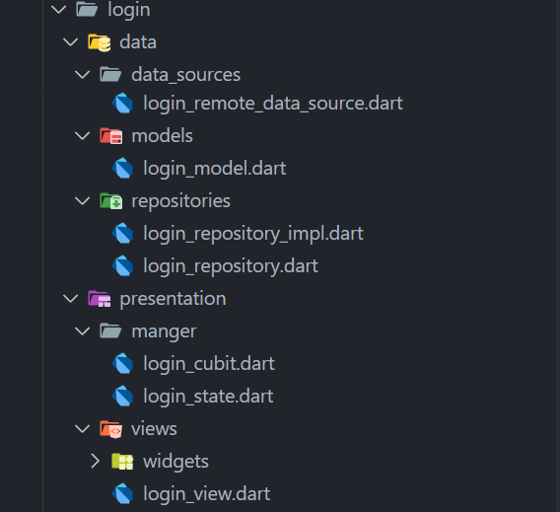

Figure 42 Feature Structure for Flutter

**Flows:**

1. **User Action:** LoginView triggers LoginCubit.submitLogin().
2. **Cubit:** Calls LoginRepository to validate data.
3. **Repository:** Uses RemoteDataSource to hit API.
4. **State Update:** LoginState notifies UI to show feedback (loading/success/error).

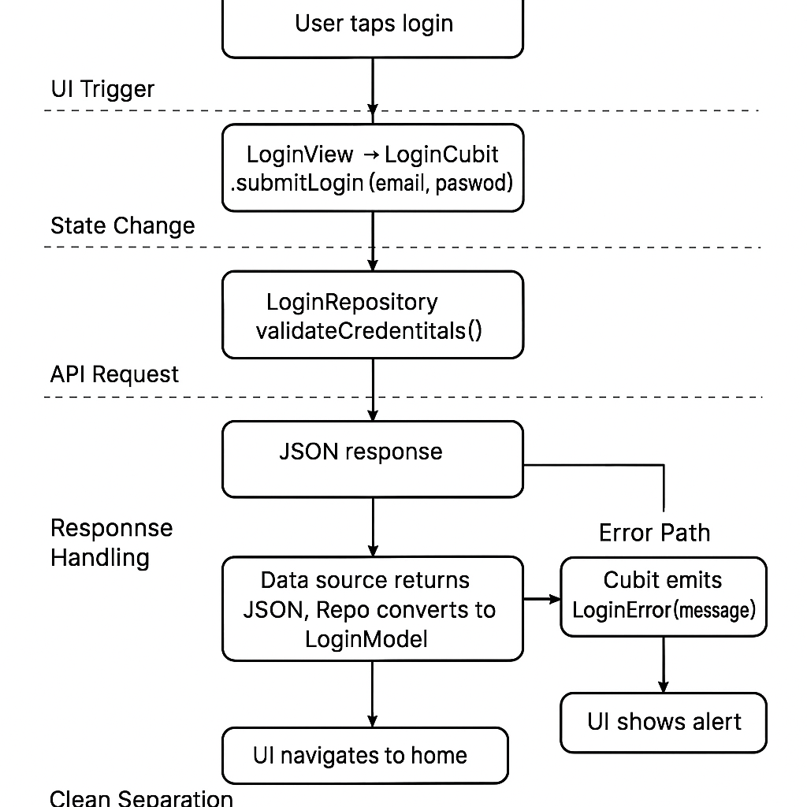

Figure 43 Workflow Diagram for Feature Structure

## 5.4.2 Authentication Process and State Handling

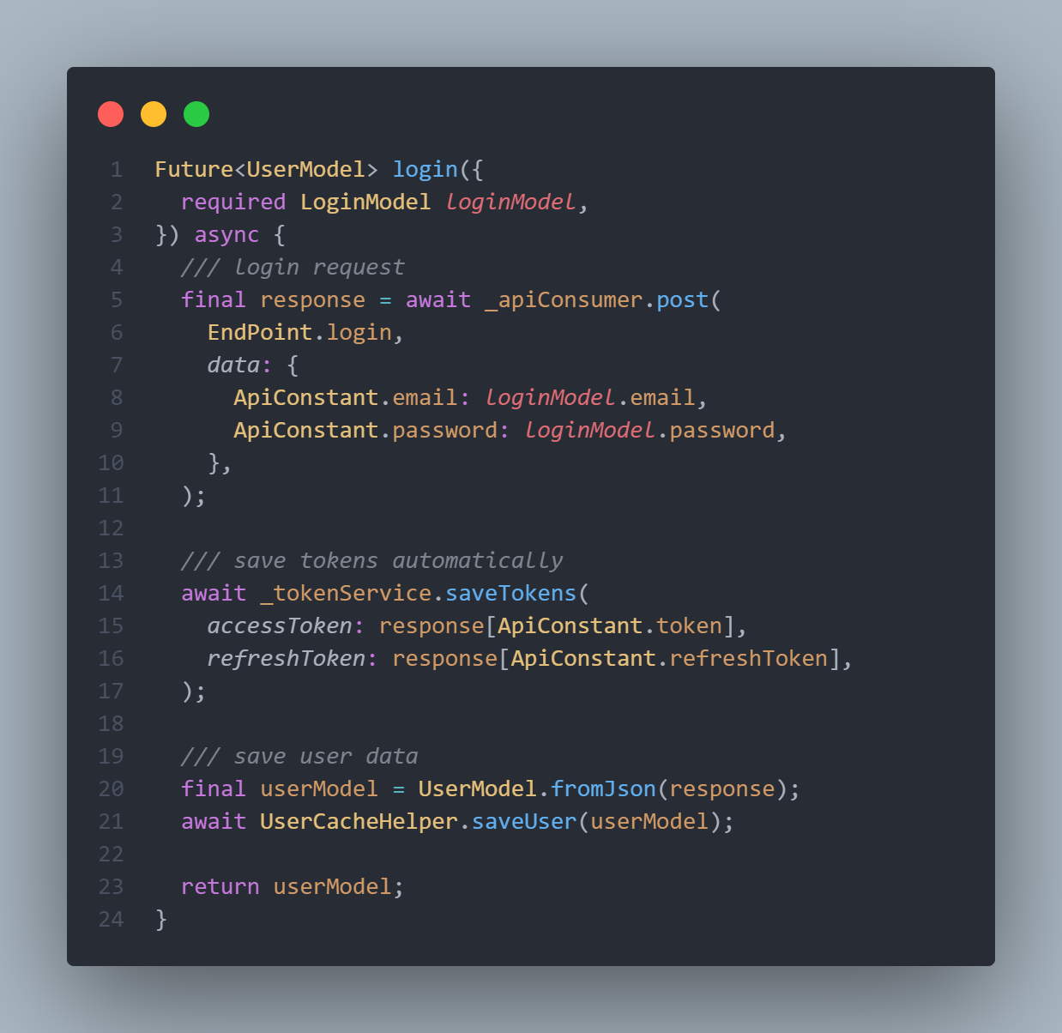

Figure 44 Login Remote Data Source

* **Remote Data Source:** This method handles the actual API call to the backend for user login. It sends the user’s email and password to the login endpoint using a POST request. Upon successful response, it extracts and stores both access and refresh tokens. It also parses the response to a UserModel and caches it locally. This abstraction ensures separation of networking logic from other layers.

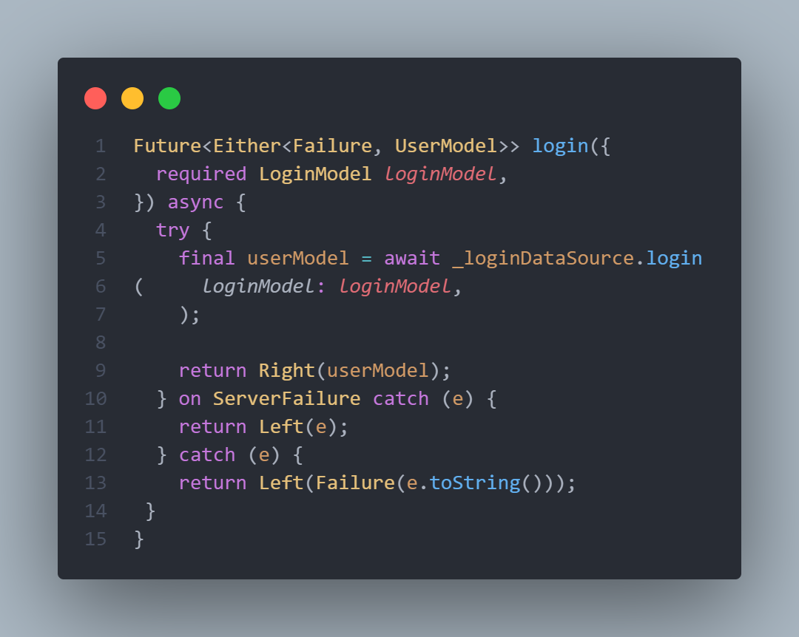

Figure 45 Login Repository

* **Repository:** This method acts as a bridge between the data source and the Manger. It calls the remote data source method and handles any exceptions that may occur. If a known Server Failure is caught, it returns a specific error message. Otherwise, it catches any unexpected errors and returns a generic failure. The method wraps the result using Either to standardize success and failure handling.

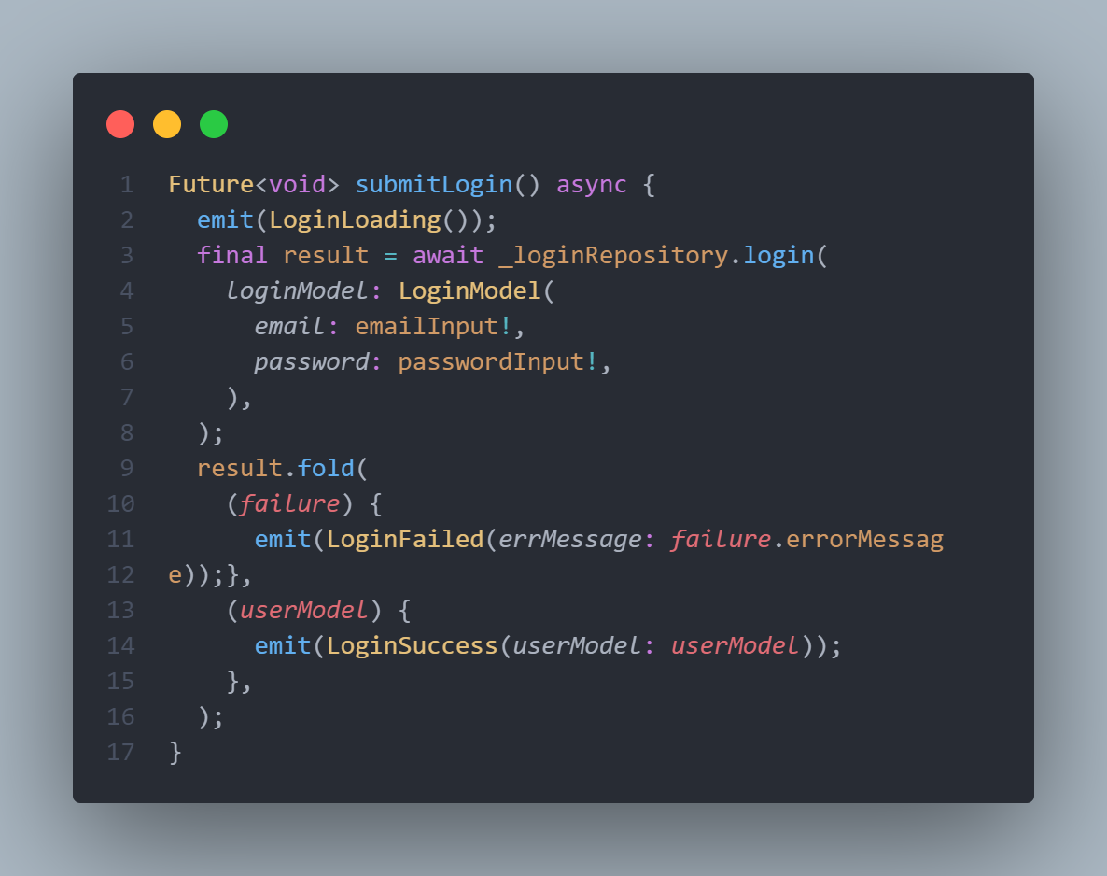

Figure 46 Cubit Submit Login

* **Cubit Function:** This function manages the authentication flow within the presentation layer. It emits a loading state before calling the login method from the repository. Based on the result, it either emits a success state with the user data, or emits a failure state containing the error message if login fails. This ensures a reactive UI that responds appropriately to login results.

## 5.4.3 Flutter Security Considerations

Security is crucial when developing mobile applications, particularly when handling sensitive data. In this section, we highlight the security practices used specifically in the Flutter application.

**Key Security Practices in Flutter:**

1. **Secure Storage:** Sensitive data, such as access tokens and user credentials, is securely stored using the [Flutter Secure Storage](https://pub.dev/packages/flutter_secure_storage) package. This package ensures that sensitive data is stored in the device’s encrypted storage, utilizing platform-specific secure storage solutions like iOS Keychain and Android Keystore.
2. **Obfuscation:** Flutter provides an option to obfuscate the Dart code during the build process. This helps make reverse engineering more difficult by obscuring the application logic and making it harder for attackers to extract sensitive information from the app
3. **Biometric Authentication:** For added security, biometric authentication (such as fingerprint or face recognition) can be implemented using the [Local Auth](https://pub.dev/packages/local_auth) package. This provides an additional layer of security for critical operations like logging in or accessing sensitive data

5.5 Backend implementation

## 5.5.1 Introduction

We used ASP.NET Core Web APIs to build the backend layer of our application. The APIs handle HTTP requests, validate input, and coordinate responses with the business logic and database. We leveraged built-in features such as routing, model binding, and dependency injection to create a flexible and scalable foundation for RESTful communication.

To maintain a clean separation between internal models and external data contracts, we utilized Data Transfer Objects (DTOs). For efficient and streamlined object mapping between entities and DTOs, we used the Mapster library, which helped reduce boilerplate code and improve maintainability.

We also implemented a custom pagination list to efficiently manage large datasets and improve performance when retrieving data in chunks. In addition, we used data caching strategies to store and reuse frequently accessed or shared data across users, reducing unnecessary database queries and enhancing overall system responsiveness.

Furthermore, we integrated middleware components to handle cross-cutting concerns like authentication, logging, and exception handling. This setup has resulted in a robust, secure, and scalable backend that integrates seamlessly with frontend architectures such as MVVM or multi-layered designs.

## 5.5.2 Account/Profile API Endpoints

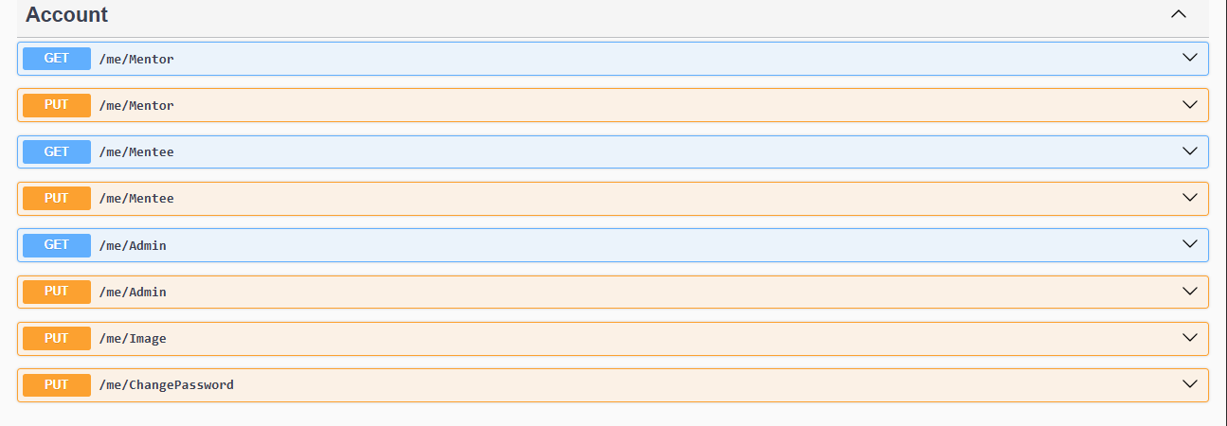

Figure 47 Account/Profile API Endpoints

* **GET / me/mentor**  
  Retrieves the profile of the currently authenticated mentor. Useful for displaying mentor profile details.
* **PUT / me/mentor**  
  Updates the profile of the currently authenticated mentor. Requires updated mentor data in the request body.
* **GET / me/mentee**  
  Retrieves the profile of the currently authenticated mentee. Useful for displaying mentee profile details.
* **PUT / me/mentee**  
  Updates the profile of the currently authenticated mentee. Requires updated mentee data in the request body.
* **GET / me/admin**  
  Retrieves the profile of the currently authenticated admin. Useful for admin-specific dashboards or controls.
* **PUT / me/admin**  
  Updates the profile of the currently authenticated admin. Requires updated admin data in the request body.
* **PUT / me/image**  
  Updates the profile image of the currently authenticated user (mentor, mentee, or admin). Typically requires a multipart/form-data request containing the new image.
* **PUT / me/changePassword**  
  Changes the password of the currently authenticated user. Requires current password and new password in the request body.

## 5.5.3 Authentication & Authorization API Endpoints

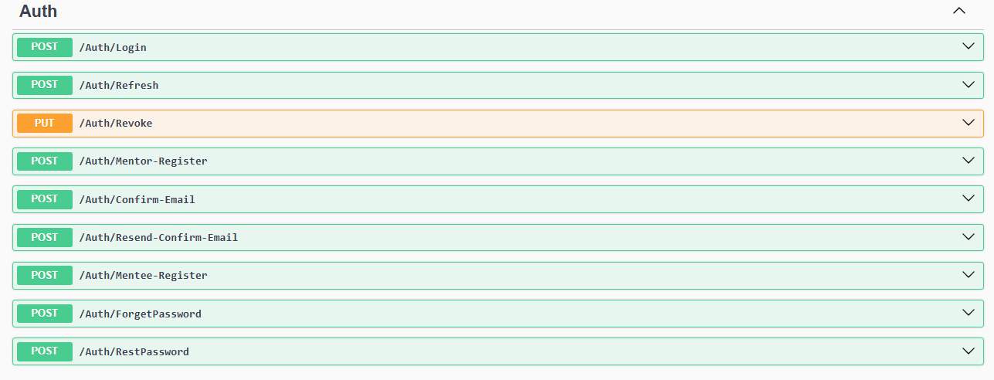

Figure 48 Authentication & Authorization API Endpoints

* **POST /auth/login**Authenticates a user using email and password. Returns access and refresh tokens on success.
* **POST /auth/refresh**Refreshes the access token using a valid refresh token. Helps maintain user sessions without re-login.
* **PUT /auth/revoke**Revokes the current refresh token, effectively logging the user out by invalidating their session.
* **POST /auth/mentor-register**Registers a new mentor account. Requires mentor registration details in the request body.
* **POST /auth/mentee-register**Registers a new mentee account. Requires mentee registration details in the request body.
* **POST /auth/confirm-email**Confirms a user's email address using a confirmation token sent via email.
* **POST /auth/resend-confirm-email**Resends the email confirmation link to the user in case the original was not received or expired.
* **POST /auth/forgetPassword**Initiates the password reset process. Sends a reset link or code to the user's email.
* **POST /auth/resetPassword**Resets the user's password using the provided reset token and new password.

## 5.5.4 Availability Time API Endpoints

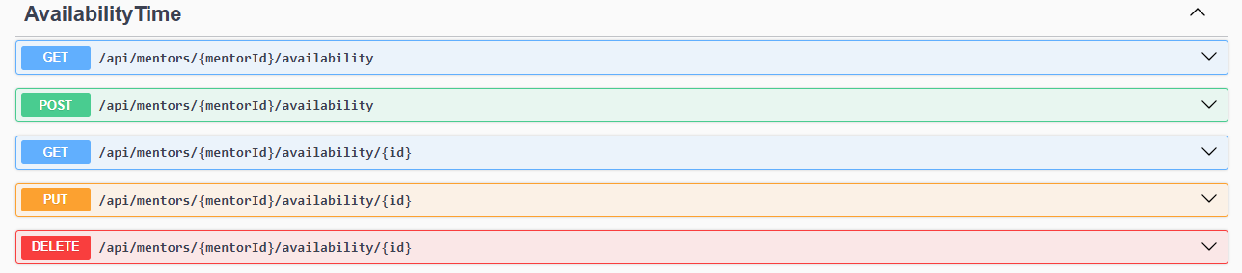**Figure 49 Availability Time API Endpoints**

* **GET /api/mentors/{mentorId}/availability**Retrieves all availability time slots for the specified mentor.
* **POST /api/mentors/{mentorId}/availability**Creates a new availability time slot for the specified mentor. Requires time data in the request body.
* **GET /api/mentors/{mentorId}/availability/{id}**Retrieves a specific availability time slot by its ID for the given mentor.
* **PUT /api/mentors/{mentorId}/availability/{id}**Updates a specific availability time slot by its ID for the given mentor.
* **DELETE /api/mentors/{mentorId}/availability/{id}**Deletes a specific availability time slot by its ID for the given mentor.

## 5.5.5 Card API Endpoints

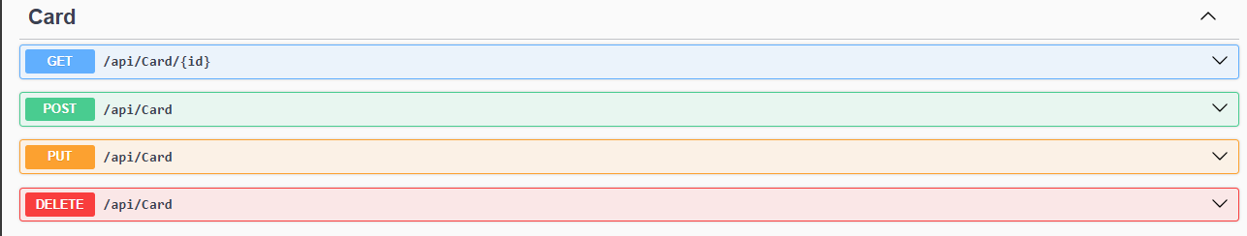**Figure 50 Card API Endpoints**

* **GET /api/card/{id}**Retrieves card information by ID. Typically used to show the user's payout card**.**
* **POST /api/card**Creates a new card entry. Used when a user submits card details to receive payments.
* **PUT /api/card**Updates existing card information. Useful for modifying payout card details.
* **DELETE /api/card**Deletes the user’s card information. Typically used if the user wants to remove their payout method.

## 5.5.6 Chat API Endpoints

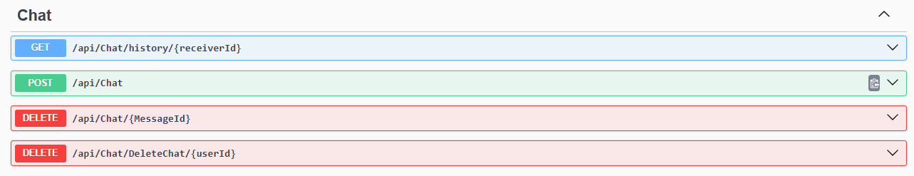**Figure 51 Chat API Endpoints**

* **GET /api/chat/history/{receiverId}**Retrieves the chat history between the authenticated user and the specified receiver.
* **POST /api/chat**Uploads a media file to the server as part of the message. Request may include image, or voice.
* **DELETE /api/chat/{messageId}**Deletes a specific message by its ID.
* **DELETE /api/chat/deletechat/{userId}**Deletes the entire chat between the authenticated user and the specified user.

## 5.5.7 Comment API Endpoints

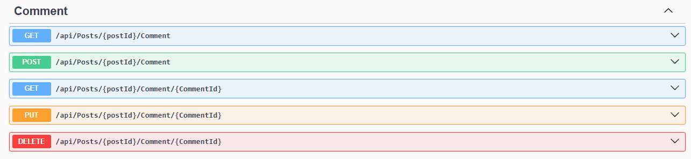**Figure 52 Comment API Endpoints**

* **GET /api/posts/{postId}/comment**Retrieves a list of all comments for the specified post.
* **POST /api/posts/{postId}/comment**Creates a new comment for the specified post. Requires comment content in the request body.
* **GET /api/posts/{postId}/comment/{commentId}**Retrieves a specific comment by its ID under the given post.
* **PUT /api/posts/{postId}/comment/{commentId}**Updates a specific comment. Requires updated comment data in the request body.
* **DELETE /api/posts/{postId}/comment/{commentId}**Deletes a specific comment by its ID.

## 5.5.8 Dashboard API Endpoints

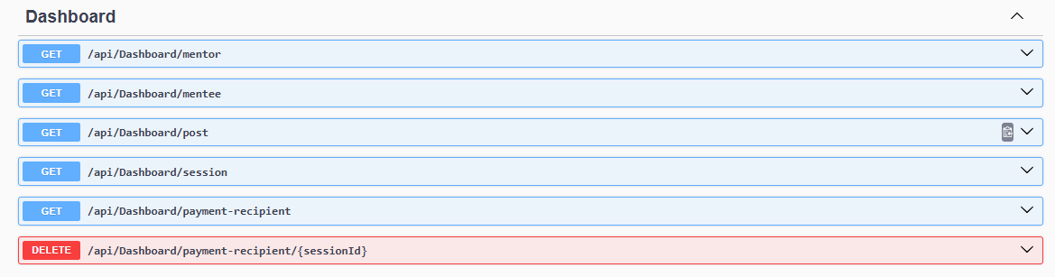**Figure 53 Dashboard API Endpoints**

* **GET /api/dashboard/mentor**  
  Returns the total number of mentors in the system.
* **GET /api/dashboard/mentee**  
  Returns the total number of mentees in the system.
* **GET /api/dashboard/post**  
  Returns the total number of posts.
* **GET /api/dashboard/session**  
  Returns the total number of sessions.
* **GET /api/dashboard/payment-recipient**  
  Retrieves a list of mentors who are eligible to receive payments, including details like name, amount, and session info.
* **DELETE /api/dashboard/payment-recipient/{sessionId}**  
  Removes a specific session from the payment recipients list (e.g., after payment is completed).

## 5.5.9 Device Token API Endpoints

**Figure 54 Device Token API Endpoints**

* **POST /api/devicetoken/add-token**Adds or updates a device token for the currently authenticated user (for FCM or push notifications).

## 5.5.10 Field API Endpoints

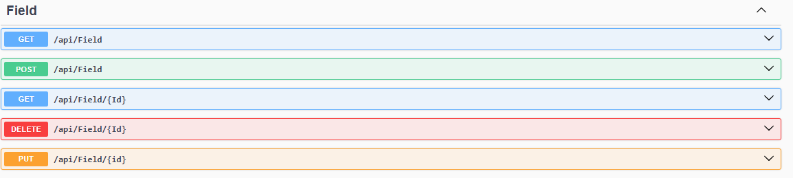**Figure 55 Field API Endpoints**

* **GET /api/field**Retrieves a list of all available fields.
* **POST /api/field**Creates a new field
* **GET /api/field/{id}**Retrieves a specific field by its ID**.**
* **PUT /api/field/{id}**Updates the name or properties of a specific field.
* **DELETE /api/field/{id}**Deletes a specific field by its ID**.**

## 5.5.11 Follow API Endpoints

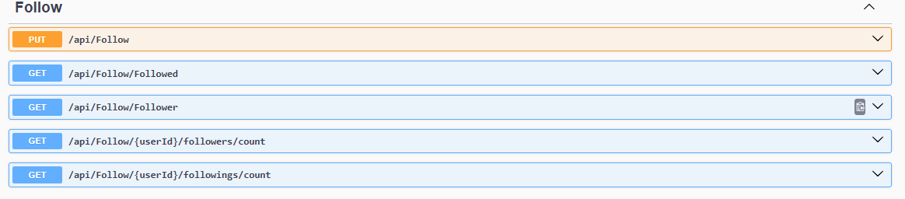**Figure 56Follow API Endpoints**

* **PUT /api/follow**Toggles the follow/unfollow status between the authenticated user and another user.
* **GET /api/follow/followed**Retrieves a list of users the authenticated user is following.
* **GET /api/follow/follower**Retrieves a list of users who are following the authenticated user.
* **GET /api/follow/{userId}/followers/count**Retrieves the number of followers for a specific user.
* **GET /api/follow/{userId}/followings/count**Retrieves the number of users that a specific user is following.

## 5.5.12 Like API Endpoints

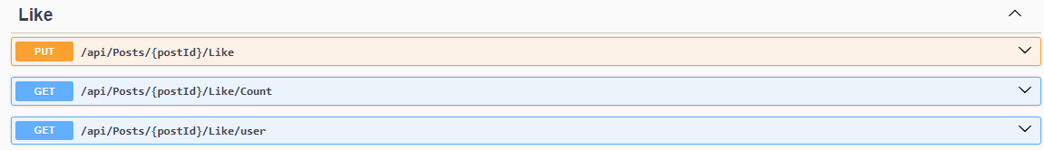**Figure 57 Like API Endpoints**

* **PUT /api/posts/{postId}/like**Toggles the like/unlike status for a specific post by the authenticated user.
* **GET /api/posts/{postId}/like/count**Retrieves the total number of likes on a specific post.
* **GET /api/posts/{postId}/like/user**Retrieves a list of users who liked the specified post.

## 5.5.13 Post API Endpoints

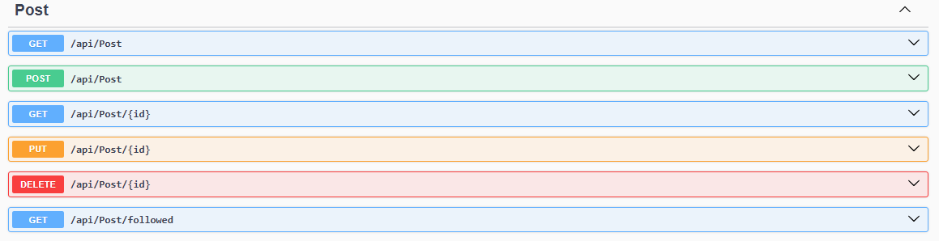**Figure 58 Post API Endpoints**

* **GET /api/post**Retrieves all posts in the system.
* **POST /api/post**Creates a new post. Requires post content (text, image, etc.) in the request body.
* **GET /api/post/{id}**Retrieves a specific post by its ID.
* **PUT /api/post/{id}**Updates a specific post. Requires updated post data in the request body.
* **DELETE /api/post/{id}**Deletes a specific post by its ID.
* **GET /api/post/followed**Retrieves posts created by users the authenticated user is following.

## 5.5.14 Result API Endpoints

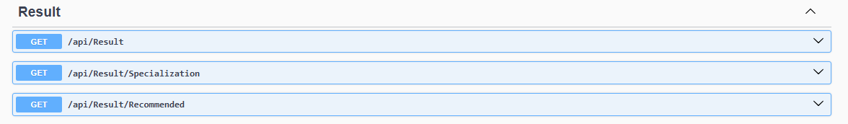**Figure 59 Result API Endpoints**

* **GET /api/result**Retrieves a list of mentors based on a general search or field filter.  
  Useful for showing mentors matching user-selected fields or keywords.
* **GET /api/result/specialization**Retrieves mentors filtered by specialization.
* **GET /api/result/recommended**Retrieves recommended mentors based on AI-generated results or model output.

## 5.5.15 Role API Endpoints

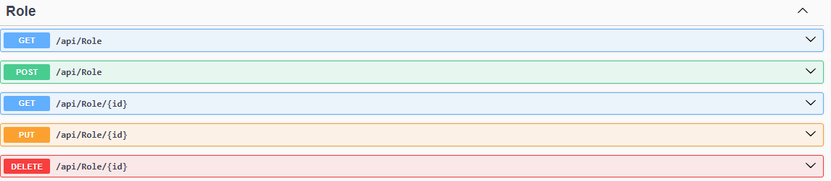**Figure 60 Role API Endpoints**

* **GET /api/role**Retrieves a list of all roles in the system.
* **POST /api/role**Creates a new role (e.g., admin, mentor, mentee).
* **GET /api/role/{id}**Retrieves details of a specific role by ID.
* **PUT /api/role/{id}**Updates a specific role’s name or permissions.
* **DELETE /api/role/{id}**Deletes a specific role by ID.

## 5.5.16 Session API Endpoints

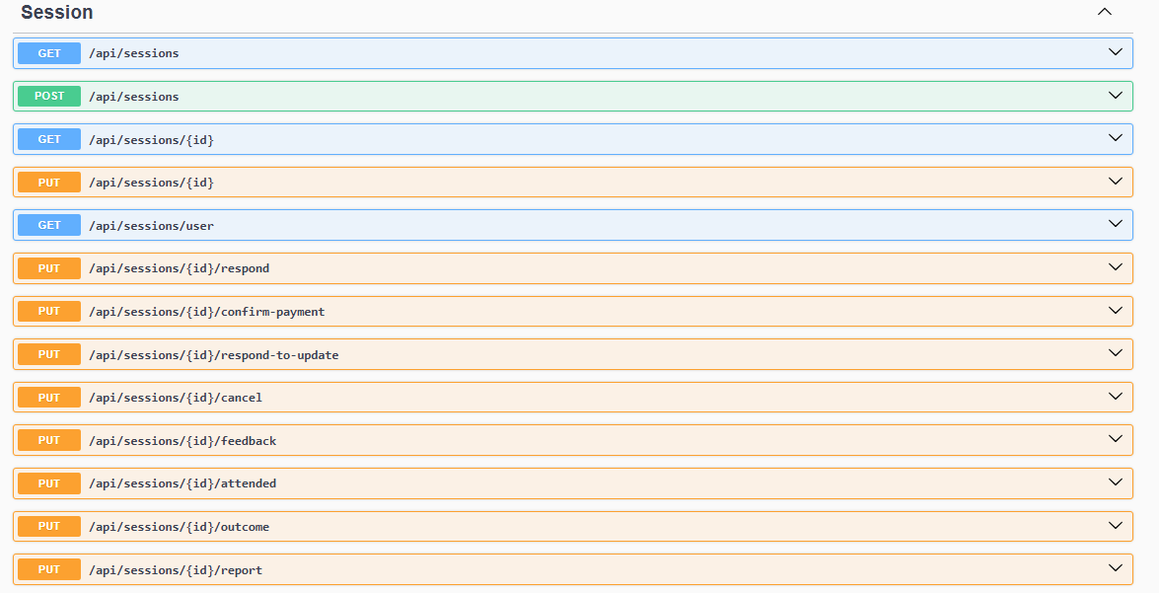

**Figure 61 Session API Endpoints**

* **GET /api/sessions**Retrieves a list of all sessions (useful for admin or global overviews).
* **POST /api/sessions**Creates a new session. Requires session details in the request body (e.g., mentor, mentee, date/time).
* **GET /api/sessions/{id}**Retrieves a specific session by its unique ID.
* **PUT /api/sessions/{id}**Updates a session's details (e.g., time change or topic).
* **GET /api/sessions/user**Retrieves all sessions associated with the currently authenticated user (mentor or mentee).
* **PUT /api/sessions/{id}/respond**Allows a mentor to accept or reject a session request.
* **PUT /api/sessions/{id}/confirm-payment**Confirms that payment has been made for the session (typically by the mentee or admin).
* **PUT /api/sessions/{id}/respond-to-update**Allows a mentor to respond to a proposed session update from the mentee.
* **PUT /api/sessions/{id}/cancel**Cancels a session (can be initiated by mentor, mentee, or admin depending on status and rules).
* **PUT /api/sessions/{id}/feedback**Submits feedback for a session after it has been completed.
* **PUT /api/sessions/{id}/attended**Marks a session as attended, typically after completion by either party.
* **PUT /api/sessions/{id}/outcome**Updates the outcome or result of a session (e.g., success, needs follow-up).
* **PUT /api/sessions/{id}/report**Generates or attaches a report to the session (can be used for admin documentation or detailed summaries).

## 5.5.17 Specializations API Endpoints

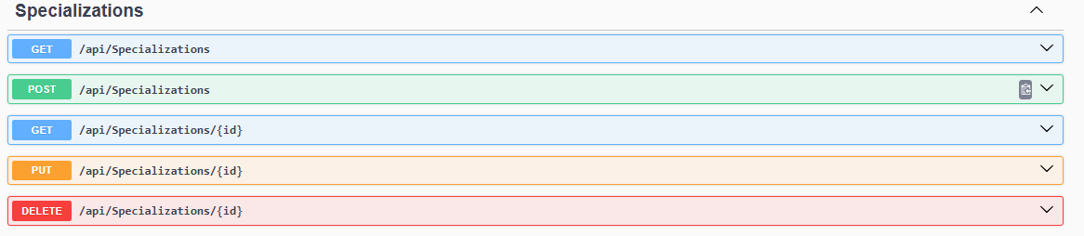**Figure 62 Specializations API Endpoints**

* **GET /api/specializations**Retrieves a list of all available specializations.
* **POST /api/specializations**Creates a new specialization (e.g., "Mobile Development").
* **GET /api/specializations/{id}**Retrieves details of a specific specialization by ID.
* **PUT /api/specializations/{id}**Updates the name or details of a specific specialization.
* **DELETE /api/specializations/{id}**Deletes a specific specialization by ID.

## 5.5.18 User API Endpoints

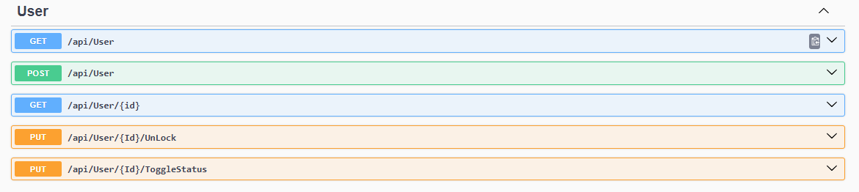**Figure 63 User API Endpoints**

* **GET /api/user**Retrieves a list of all users in the system.
* **POST /api/user**Creates a new user. Requires user data such as email, password, and role.
* **GET /api/user/{id}**Retrieves a specific user by ID.
* **PUT /api/user/{id}/unlock**Unlocks a user account (typically after being locked due to failed login attempts or admin action).
* **PUT /api/user/{id}/togglestatus**Toggles the active/inactive status of a user account (e.g., for banning or restoring access).

**Chapter 6:**

**Mentorea AI**

6.1 Abstraction

This chapter explores the integration of artificial intelligence (AI) within the Mentorea Platform, a mentorship ecosystem designed to connect mentees with qualified mentors.

The AI-driven components include a recommendation system, sentiment analysis, and a CV checker, each tailored to enhance platform functionality and user experience.

The recommendation system leverages user data to suggest optimal mentor-mentee matches based on preferences, expertise, and goals.

The Sentiment analysis processes mentee feedback on mentors, transforming qualitative comments into actionable insights to assess mentor performance and improve pairings, and ensure that the Mentorea community is more respectful interactions among all users.

The CV checker evaluates mentor applications by analyzing qualifications, experience, and skills to ensure only suitable candidates are onboarded. Together, these AI modules streamline operations, foster meaningful mentorship connections, and maintain high standards for mentor quality, contributing to the platform’s mission of effective knowledge transfer and professional growth.

6.2 Mentorea Recommendation System

## 6.2.1 Introduction

The Mentorea platform facilitates mentorship by connecting mentees with mentors based on skills, preferences, and interaction history. The recommendation system is a core component, providing personalized mentor suggestions to enhance user experience. It addresses two scenarios: recommending mentors for mentees with interaction history using collaborative filtering and handling cold-start mentees (those without interactions) using content-based filtering. The system is built with Python, utilizes the Flask framework for API development, and is deployed on the Railway server for robust hosting.

## 6.2.2 System Overview

The recommendation system combines two methodologies:

1. **Collaborative Filtering with LightFM: Uses user-mentor interaction data and feature matrices to recommend mentors for mentees with prior interactions.**
2. **Content-Based Filtering: Matches mentors to mentees based on skills, location, average rating, availability, and experience years, particularly for cold-start mentees.**

## 6.2.3 Technical Implementation

6.2.3.1 Dependencies and Setup

The system relies on the following Python libraries, installed via the command:

**All of them at requirements.txt**

|  |
| --- |
| !pip install pandas numpy scikit-learn lightfm matplotlib seaborn plotly flask scipy  !pip install -r requirements.txt |

**Library versions:**

* Python: 3.11.12
* pandas: 2.2.2
* numpy: 2.0.2
* scikit-learn: 1.6.1
* lightfm: 1.17
* scipy: 1.15.3 (required for LightFM)
* flask: 3.1.1

6.2.3.2 Data Loading

The system uses synthetic (dummy) datasets loaded from CSV files for exploratory data analysis (EDA) and model training:

* **Interaction Data: Loaded from All_Interaction_recomendation.csv, containing session details such as “SessionId,MentorId, MenteeId, ScheduledTime, DurationMinutes, Price, Rating, and Feedback_value”.**
* **Mentee Data: Loaded from Mentees.csv, including mentee profiles with attributes “Id, Name,BirthDate,Location,Gender,About,IsDisabled,UserName,NormalizedUserName, Email,NormalizedEmail,EmailConfirmed,PasswordHash,SecurityStamp,ConcurrencyStamp, LockoutEnabled, FieldName”.**
* **Mentor Data: Loaded from Mentors_recomendation.csv, containing mentor profiles with attributes like “Id, Name, Email, Location, Rate, PriceOfSession, NumberOfSession, About, and FieldId”.**

**The datasets are read using pandas:**

|  |
| --- |
|  |

Figure 64 The datasets are read using pandas

**Trained models and feature matrices are loaded from pickle files for inference:**

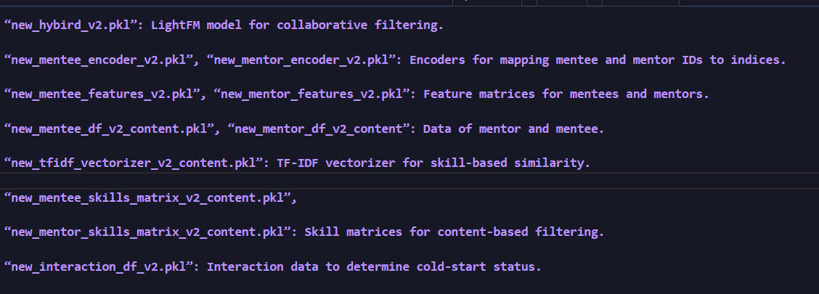

Figure 65 Trained models and feature matrices are loaded from pickle files for inference

6.2.3.3 Recommendation Logic

The system implements three recommendation functions:

**1. recommend_mentors (mentee_id, top_k):** Uses the LightFM model to recommend mentors for mentees with interaction history. It transforms the mentee ID to an index, predicts scores for all mentors (96 mentors), and returns the top top_k mentors (default 9).

**2. recommend_mentors_content_based (mentee_id, top_k, weights):** For coldstart mentees with metadata, it computes similarities based on skills, location, average rating, availability, and experience years, using weights (skills: 0.5, location: 0.1, avg_rate: 0.25, avg_availability: 0.07, experience_years: 0.08).

**3. recommend_mentors_content_based_skills (m_skills, top_k, weights):** For mentees without metadata, it uses provided skills to compute TF-IDF vectors and recommends mentors based on skill similarity, So weights (skills: 1).

**4. The API endpoint /recommend:** accepts a JSON payload with mentee_id and m_skills, determines the appropriate recommendation method, and returns a list of mentor IDs with additional details (e.g., name, email, location).

6.2.3.4 API Endpoint

The Flask application exposes a POST endpoint at /recommend:

* **Input:** JSON payload with mentee_id (string UUID) and m_skills (list of strings).
* **Output**: JSON response containing the mentee ID, recommendation method, and a list of recommended mentor details (mentor_id) for backend to get all data about mentors.
* **Error Handling**: Returns HTTP status codes (400 for invalid input, 500 for server errors)

**Example request and response:**

|  |
| --- |
| { "mentee_id": "123e4567 -e89b -12d3-a456 -426614174000", "m_skills": ["Python", "Machine_Learning"]  } |

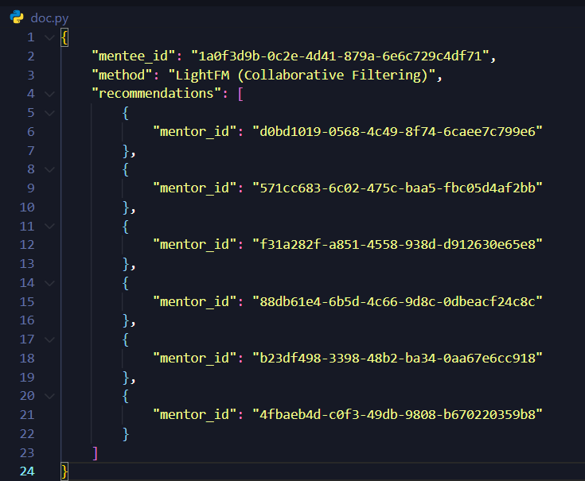

Figure 66 Example request

6.2.4 Deployment on Railway

The application is deployed on the Railway platform, a cloud hosting service optimized for web applications. The deployment process involves:

1. **Project Setup:** A Railway project is created, and the application code is pushed to a GitHub repository linked to Railway**.**
2. **the application code**: all DataFrame, Trained Models, Requirements File and Docker file
3. **Environment Configuration**: The PORT environment variable is set (defaulting to 5000) to configure Flask’s server**.**
4. **Dependency Management**: A requirements.txt file lists all dependencies for automatic installation.
5. **File Hosting**: Pickle files are uploaded to the Railway environment or a connected storage service.
6. **Runtime**: Railway runs the Flask app using a WSGI server (e.g., gunicorn), binding to 0.0.0.0 and the specified port.

**Railway’s autoscaling and monitoring ensure responsiveness under varying loads.**

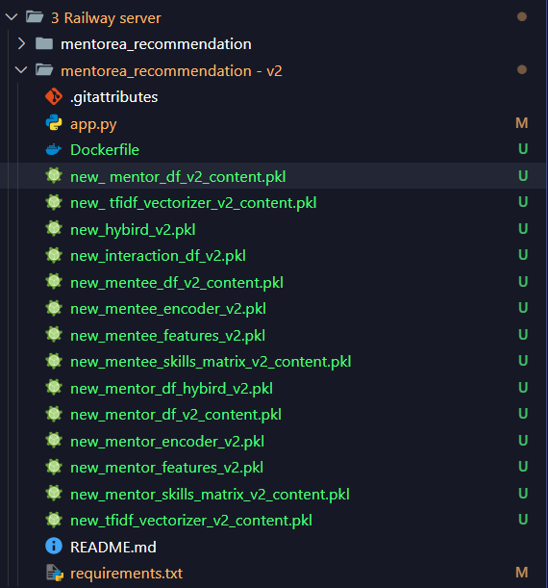

Figure 67 Railway’s autoscaling and monitoring ensure responsiveness under varying loads

**Recommendation System Steps:**



Figure 68 Recommendation System Steps

6.2.5 Conclusion

The Mentorea recommendation system effectively combines collaborative and contentbased filtering to provide personalized mentor recommendations using synthetic data.

The LightFM model leverages interaction data, while TF-IDF-based similarity addresses cold-start scenarios. The Flask-based API and Railway deployment ensure a scalable, accessible solution for the Mentorea platform.

**Notebook Code**

<https://colab.research.google.com/drive/1SR_TJxs9BqRcBvR4sEwfQvpUs15VzQiS#scrollTo=C05qIFMtcvaD>

6.3 CV Checker for Mentorea Platform

## 6.3.1 Introduction

The Mentorea Platform aims to facilitate effective mentorship by connecting mentees with qualified mentors. A critical component of this ecosystem is the AI-driven CV Checker, designed to evaluate the qualifications of mentor applicants. This tool ensures that only candidates meeting specific professional and interpersonal criteria are onboarded as mentors, thereby maintaining high mentorship standards. The CV Checker leverages natural language processing (NLP) and machine learning to analyze resumes, assessing experience, skills, and suitability.

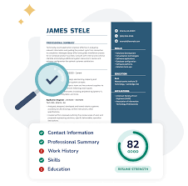

Figure 69 CV Checker

## 6.3.2 System Overview

The CV Checker is an automated system that processes PDF resumes submitted by mentor applicants. It extracts text from these documents and evaluates the content against predefined criteria for mentorship eligibility. The system integrates with the Groq API, utilizing the LLaMA model to perform in-depth analysis. Key functionalities include:

* **Text Extraction**: Converts PDF resumes into machine-readable text using PyPDF2.
* **CV Analysis**: Assesses qualifications, including at least three years of professional experience (inclusive of project contributions), leadership or mentoring experience, communication skills, relevant education or certifications, and soft skills like

empathy and problem-solving.

* **Scoring and Recommendation**: Generates a mentor eligibility score (0–100) and

provides a JSON-formatted output with a summary, strengths, gaps, and a recommendation. Candidates scoring 75 or higher are deemed suitable for mentorship

roles.

The system is accessible via a Flask-based API, allowing seamless integration into the

Mentorea Platform for real-time CV evaluation.

## 6.3.3 Technical Implementation

6.3.3.1 Dependencies and Setup

The CV Checker relies on a robust set of Python libraries and tools to function effectively.

The primary dependencies include:

* **PyPDF2 (v3.0.1):** For extracting text from PDF resumes.
* **Groq (v0.26.0):** To interface with the LLaMA model for CV analysis.
* **Flask (v3.1.1):** To create a RESTful API for CV processing.
* **pyngrok(v7.2.11):** For exposing the local server to the internet during development.
* **python-dotenv (v1.1.0):** For managing environment variables, such as the Groq API key.

To set up the environment, the following command installs the required packages:

|  |
| --- |
| !pip install -r requirements.txt  !pip install groq PyPDF2 pyngrok dotenv |

The system requires a Groq API key, which is securely stored in an environment variable (GROQ_API_KEY). The setup ensures compatibility with Python 3.11 and is tested in a cloud environment (e.g., Google Colab with GPU acceleration).

The core implementation consists of several Python functions:

* **extract_text_from_pdf(pdf_path):** Opens a PDF file, extracts text from each

page using PyPDF2 and returns the concatenated text. It handles exceptions and

ensures no empty text is processed.

* **analyze_cv(cv_text):** Sends the extracted text to the Groq API with a prompt

defining mentor criteria. The LLaMA model (llama3-70b-8192) processes the text

and returns a JSON response with a summary, score, strengths, gaps, and recommendation.

* **evaluate_mentor_cv(pdf_path):** Orchestrates the process by calling the extraction and analysis functions, returning the final evaluation.

The Flask API endpoint (/upload_pdf) accepts POST requests with PDF files, saves them temporarily, processes the content, and returns the analysis result. The uploaded files are deleted after processing to maintain security and manage storage.

**CV Checker Example:**

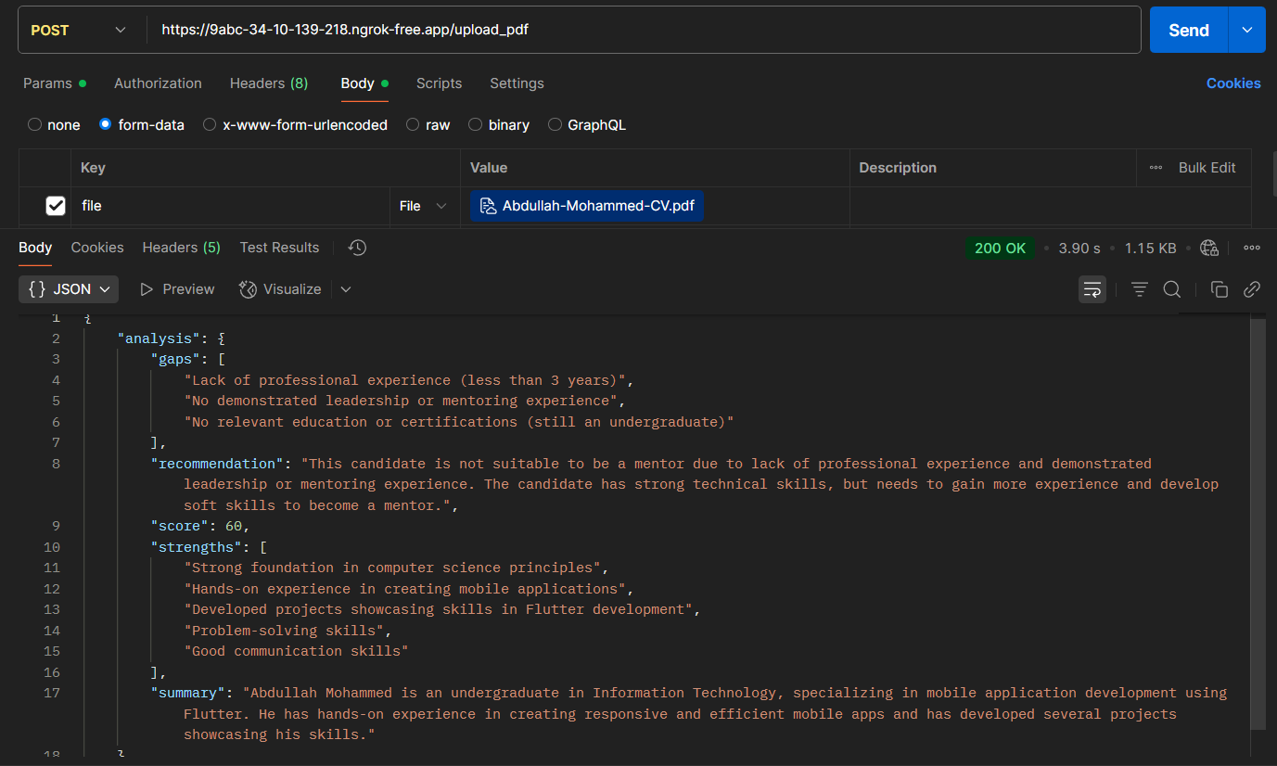

Figure 70 Example of CV Checker

If the user can’t be a mentor, LLM model will provide them all gaps at his CV.

## 6.3.4 Deployment

The CV Checker is deployed as a Flask application, making it accessible via a RESTful API.

**The deployment process involves:**

**1. Local Development:** The application is tested locally using Flask’s development server. The pyngrok library exposes the local server to a public URL for testing, configured with an authentication token:

|  |
| --- |
| !ngrok config add-authtoken <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> |

**2. API Integration:** The /upload_pdf endpoint is integrated into the Mentorea Platform’s backend, allowing mentor applicants to upload CVs via a web interface. The endpoint processes the PDF and returns the JSON analysis, which is used to inform onboarding decisions.

**3. Security Measures:** Environment variables manage sensitive data (e.g., API keys). Uploaded PDFs are stored temporarily in a secure directory (./uploaded_pdfs) and deleted after processing. HTTPS is enforced for all API communications.

**4. Scalability:** The system is designed to handle multiple concurrent requests, with the Groq API providing scalable NLP capabilities. Load balancing and auto-scaling are implemented on the cloud server to manage high traffic.

The public URL generated by ngrok during development (e https://cb58-34-124-169-232.ngrok-free.app) is replaced with a stable domain in production. The deployment ensures high availability, security, and integration with the Mentorea Platform’s mentorship workflow.

**CV Checker Steps**

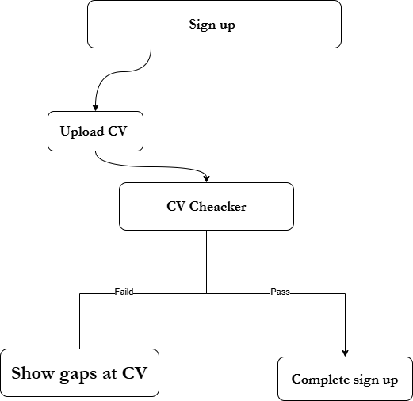

Figure 71 CV Checker Steps

**Notebook Code**

<https://colab.research.google.com/drive/1WCqF_7suAm3kTEO02jXQuqeVp9DRmEpq?usp=sharing>

6.4 Sentiment Analysis

## 6.4.1 Introduction

The Mentorea Platform fosters a supportive mentorship ecosystem by connecting mentees with qualified mentors and maintaining a respectful community environment. The sentiment analysis model is a pivotal AI component that evaluates mentee feedback about mentors and rates comments within the Mentorea community to ensure respectful interactions among all users. By analyzing Arabic or English text inputs, the model identifies positive, neutral, or negative sentiments, incorporating rule-based logic to address culturally specific expressions and offensive language. This chapter details the system’s design, technical implementation, and deployment, highlighting its dual role in enhancing mentorship quality and promoting a positive community atmosphere.

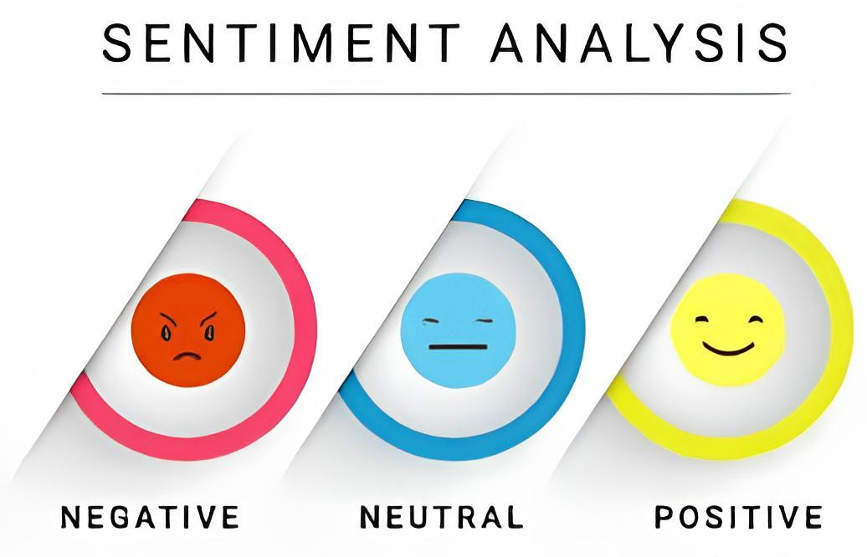

Figure 72 Sentiment Analysis

## 6.4.2 System Overview

The sentiment analysis system processes Arabic or English text inputs, such as mentee feedback and community comments, to assign sentiment labels (positive, neutral, negative) and numerical values on a 1–10 scale. It combines a pre-trained transformer model with custom rules to handle Arabic and English colloquialisms and enforce community standards.

**Key functionalities include:**

* **Text Analysis:** Utilizes the **CAMeL-Lab/bert-base-arabic-camelbert-mix-sentiment** model to classify sentiment and compute confidence scores for feedback and comments at Arabic. And **distilbert-base-uncased-finetuned-sst-2-english** to classify sentiment and compute confidence scores for feedback and comments at English.
* **Rule-Based Overrides:** Identifies offensive terms (e.g., ,”****” ) to flag negative sentiment and detects laughter patterns to adjust sentiment toward negative in potentially disrespectful contexts.
* **Value Mapping:** Maps sentiment and confidence to a 1–10 scale, with positive sentiments ranging from 7.1–10, neutral from 4.1–7, and negative from 1–4 (specially very bad 1-2), aiding in mentor evaluation and comment moderation.
* **Community Moderation:** Rates community comments to identify disrespectful or inappropriate content, supporting a respectful and inclusive environment.
* **API Access:** Offers a Flask-based RESTful API endpoint (/analyze) for real-time sentiment analysis of text inputs.

By analyzing both mentorship feedback and community interactions, the system ensures high quality mentor-mentee pairings and fosters respectful communication across the platform.

## 6.4.3 Technical Implementation

6.4.3.1 Dependencies and Setup

The sentiment analysis system relies on a set of Python libraries to deliver robust functionality. The primary dependencies include:

* **Flask:** For creating a RESTful API to process text analysis requests.
* **Transformers:** Provides the pipeline for loading and running the BERT-based sentiment analysis model.
* **pyngrok:** Exposes the local server to a public URL during development.
* **re:** Enables regular expression matching for detecting laughter patterns.

To set up the environment, the following command installs the required packages:

|  |
| --- |
| !pip install flask transformers Pyngrok langdetect |

The system employs the **CAMeL-Lab/bert-base-arabic-camelbert-mix-sentiment** and **distilbert-base-uncased-finetuned-sst-2-english** models, are a BERT-based model fine-tuned for Arabic and English sentiment analysis, accessed via the Hugging Face transformers library. The setup is compatible with Python 3.11 and tested in cloud environments (Google Colab).

**The core implementation comprises:**

* analyze_sentiment(text): Processes input text by applying the sentiment pipeline,

checking for insults and laughter patterns and overriding sentiment when necessary. It maps results to a 1–10 value using map_sentiment_to_value.

* map_sentiment_to_value(sentiment, confidence): Converts sentiment labels and confidence scores to a numerical value, ensuring distinct ranges for positive, neutral, and negative sentiments.
* analyze Endpoint: A Flask POST endpoint that accepts JSON input with a text field, validates it, and returns a JSON response with sentiment, confidence, and value, used for both feedback analysis and comment moderation.

And We detect is text Arabic or English by **langdetect library.**

The system maintains a predefined list of Arabic or English insults and a regular expression ({,3}) to detect laughter, ensuring accurate identification of disrespectful or informal content in community interactions.

## 6.4.4 Deployment

The sentiment analysis model is deployed as a Flask application, integrated into the Mentorea Platform via a RESTful API. The deployment process includes:

**1. Local Development:** The application runs locally on port 5000 using Flask’s debug

server. The pyngrok library generates a public URL for testing, configured with an authentication token:

|  |
| --- |
| !ngrok config add-authtoken <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> |

**2. API Integration:** The /analyze endpoint is embedded in the Mentorea Platform’s backend, processing mentee feedback and community comments submitted via the platform’s interface. Results inform mentor evaluations and flag disrespectful comments for moderation.

**3. Scalability:** The transformer model is optimized for inference, and the Flask application handles concurrent requests efficiently. Cloud-based load balancing and auto-scaling address high traffic during peak community activity.

The public URL provided by ngrok during development (https://<ngrok-id>.ngrok-free.app) is replaced with a stable domain in production. The deployment ensures secure, scalable, and reliable sentiment analysis, supporting the Mentorea Platform’s goals of enhancing mentorship quality and fostering a respectful community environment.

**Sentiment Analysis Steps:**

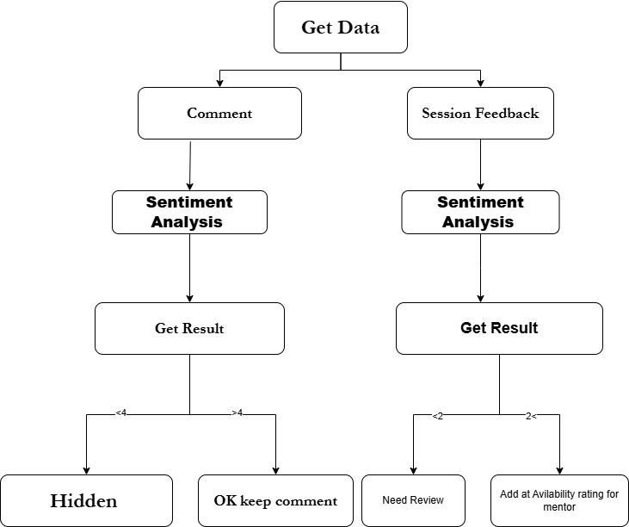

Figure73 Sentiment Analysis Steps

**Notebook Code:**

<https://colab.research.google.com/drive/1YB3B7afGYmLt1ofDEvAQ0t3lR6mLO89b?usp=sharing>

Conclusion

The Mentorea platform represents a significant advance in addressing the challenges of traditional mentoring, leveraging digital technology to create a scalable, accessible, and effective mentoring ecosystem. By integrating a robust set of features specifically designed for both mentors and mentees, such as profile management, session scheduling, instant chat, and AI tools such as a recommendation system, resume checker, and sentiment analysis, Mentorea helps bridge critical gaps in mentoring accessibility and personalization. The platform's user-centric design, implemented through an intuitive Figma UI and a secure Flutter-based mobile app, ensures a seamless user experience. Its back-end infrastructure, with its comprehensive API endpoints, supports reliable and secure data processing, while AI components enhance mentor-mentee matching, career guidance, and engagement quality.

Through careful project management, risk identification, and system analysis, the development process addressed both functional and non-functional requirements, ensuring scalability, security, and performance. The literature review highlighted the importance of mentoring and the limitations of traditional models, which Mentoria overcomes by offering a digital solution that promotes meaningful communication and professional growth. The implementation of AI-powered features makes Mentoria a leading platform capable of adapting to evolving user needs.

While the platform successfully achieves its goals, future work could focus on expanding AI capabilities, incorporating additional features such as video conferencing, and improving accessibility for diverse user groups. Mentoria is a transformative tool in the mentoring field, enabling mentors and mentees to communicate, collaborate, and grow in a dynamic digital environment.

**Now you can learn with Experts.**

Future Work

**1. Ai Interviewer:** To make sure that only the best can be a mentor.

**2. Ai Notes:** To take Note for all this happen at session between mentee and mentor, for analysis after that and sent all note for mentee if he forgets something.

**3. Computer Vision model**: To make an analysis for mentor actions, his focus, and his availability at session.

**4. chat bot is customized at our platform:** to answer any question about Mentorea answer about mentors and skills, and provide an information about tracks or fields like road map, information.

**5. Another language:** Like French and Deutsche**.**

**6. Full payment system**